
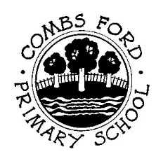
SMSC and British Values at Combs Ford Primary School

Spiritual Development  - Ability to be reflective about their own beliefs (religious or otherwise) and perspective on life  - Knowledge of, and respect for, different people’s faiths, feelings and values  - Sense of enjoyment and fascination in learning about themselves, others and the world around them  - Use of imagination and creativity in their learning  - Willingness to reflect on their experiences | Moral Development  - Ability to recognise the difference between right and wrong and to readily apply this understanding in their own lives, and to recognise legal boundaries and, in doing so, respect the civil and criminal law of England  - Understanding of the consequences of their behaviour and actions  - Interest in investigating and offering reasoned views about moral and ethical issues and ability to understand and appreciate the viewpoints of others on these issues | Social Development  - Use of a range of social skills in different contexts – for example, working and socialising with other pupils, including those from different religious, ethnic and socio-economic backgrounds  - Willingness to participate in a variety of communities and social settings, including by volunteering, cooperating well with others and being able to resolve conflicts effectively  - Acceptance of and engagement with the fundamental British values of democracy, the rule of law, individual liberty and mutual respect and tolerance of those with different faiths and beliefs. They will develop and demonstrate skills and attitudes that will allow them to participate fully in and contribute positively to life in modern Britain | Cultural Development  - Understanding and appreciation of the wide range of cultural influences that have shaped their own heritage and that of others  - Understanding and appreciation of the range of different cultures in the school and further afield as an essential element of their preparation for life in modern Britain  - Ability to recognise, and value, the things we share in common across cultural, religious, ethnic and socio-economic communities  - Knowledge of Britain’s democratic parliamentary system and its central role in shaping our history and values, and in continuing to develop Britain  - Willingness to participate in and respond positively to artistic, musical, sporting and cultural opportunities  - Interest in exploring, improving understanding of, and showing respect for different faiths and cultural diversity and the extent to which they understand, accept, respect and celebrate diversity. This is shown by their respect and attitudes towards different religious, ethnic and socio-economic groups in the local, national and global communities
Combs Ford Core Values
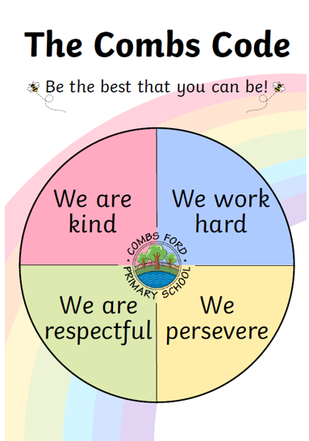

Conventions of the Rights of the Child  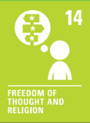  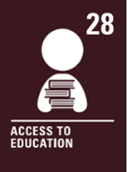  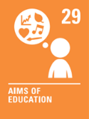  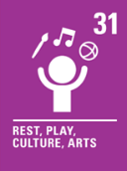  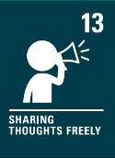  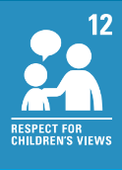 | Conventions of the Rights of the Child  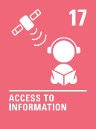   | Conventions of the Rights of the Child  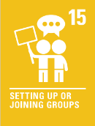  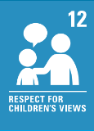 | Conventions of the Rights of the Child  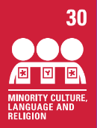
Spiritual Development | Moral Development | Social Development | Cultural Development
Curriculum  - RE: Emmanuel Project teaching units including visits to local church  - PSHE/RSE: Jigsaw 3-11  - Opportunities across the curriculum to encourage wonder & imagination (e.g., writing, art, music, dance, science)  - The use of different learning styles along with resources.  - AFL development throughout the school  - Use of reading shed at Play and lunch time  - All year groups participate in units of Geography work that promote enjoyment and fascination in others around the world. | Curriculum  - RE: Emmanuel Project teaching units  - *PSHE/RSE: Jigsaw 3-11  - *Online safety lessons  - Use of reading shed at Play and lunch time | Curriculum  - *PSHE/RSE: Jigsaw 3-11  - *Team games and outdoor adventurous activities in PE lessons  - *Sports days  - *Use of talk partners throughout the curriculum  - Forest schools  - Use of reading shed at Play and lunch time  - In Geography all year groups using talk time and group work within lessons. A variety of partner work and group work is used regularly in lessons. | Curriculum  - *Diversity of reading books  - *Use of local area for geography fieldwork  - *Teaching of French across KS2  - Use of reading shed at Play and lunch time  - In Geography all year groups look at their local area and study an area in the wider world looking at difference and similarities etc…
Whole School Events  - Whole school assemblies  - Celebration Assembly  - School Council  - Christmas Nativity (EYFS)  - Christmas Performance (Key Stage 1)  - Harvest Festival – Vicar from the local church  - Christmas service- Vicar from the local church Y1-Y6  - Extra-curricular clubs  - Art Day  - Rainbow Rights Rangers (UNCRC steering group) | Whole School Events  - Behaviour policy- This reinforces British Values  - The Combs Code  - Whole school assemblies  - Celebration Assembly  - School Council  - Online safety lessons  - PC visits e.g. focus on road safety  - Displays in schools promote interest in issues (School council)  - Harvest- Donations go the local food bank.  - British Values display | Whole School Events  - Whole school assemblies  - The Combs Code- consistent throughout the school  - Charity fundraising – half-termly non-uniform days, donations to local food bank, Children in Need, Christmas Jumper Day  - School Council  - Remembrance Day  - Art Day  - Article 30 Minority Languages Assembly  - Children awarded team points when children have shown examples of the school values. | Whole School Events  - Whole school assemblies  - Celebration of key dates e.g. Bonfire Night, St George’s Day, Diwali  - Elections for School Council representatives  - Classroom voting e.g. for books to read in EYFS  - National Sports Week events  - World Book Day  - Performances – Christmas, musicals, leavers’ assembly, Rock Steady concerts  - Art Day  - International Art Day  - Article 30 Minority Languages Assembly  - European Day of Languages
Specific Year Group Opportunities | Specific Year Group Opportunities | Specific Year Group Opportunities | Specific Year Group Opportunities
EYFS  - ‘In Early Years we are …’ – EYFS  - Role play  - Music area  - Drawing Club  - Sparkly Start  - Access to the outdoor area  - Visitors- Ice cream van, hedgehog/owl and Mini Monsters  - Understanding where our school is and what it is like | EYFS  - ‘In Early Years we are …’ - EYFS  - A focus on litter and looking after our immediate environment  - EYFS weekly celebration | EYFS  - ‘In Early Years we are …’ EYFS  - Focus on PSED  - Independent learning time ‘Busy Time’ where they learn to negotiate and take turns  - Games  - Wow Writer  - Classroom responsibilities | EYFS  - EYFS ‘In Early Years we are …’  - Days to celebrate other celebrations siuch as Chines New Year and Diwali  - Celebrating significant unique events e.g. Jubilee, Coronation  - Developing an understanding of same and different  - Mystery Reader
Year 1  - Visits from Rev Sarah Jenkins for RE  - Rock Steady (Y1-6)  - Story time- Books chosen to raise awareness of cultures, illnesses, disabilities etc and link to particular days e.g. National Deaf Awareness Week | Year 1  - In Geography they look at the rainforest and touch on how it is being destroyed and the impact of this. | Year 1  - Trip to Felixstowe Beach  (paddling, sandcastle building)  - Teaching children how to behave in school and socialise with others.  - PCSO – Road traffic awareness  - Music lessons- children to work together | Year 1  - Trip to Felixstowe Beach  (paddling, sandcastle building)  - Look at traditional tales from Africa  - Compare Combs Wood and the Rainforest  - Reading books from different cultures  - Music lessons- Music from around the world
Year 2  - Singing assemblies  - Rock Steady (Y1-6) | Year 2  - Story time | Year 2  - ‘Helping Hands’ for classroom jobs  - Story time  - Show and Tell | Year 2  - Viking Day (TBC)  - Music Lessons (External teacher)  - Year 2 local area walk  - Singing assemblies  - Visit to St Edmundsbury Cathedral – Year 2
Year 3  - Rock Steady (Y1-6) | Year 3  - Deforestation writing unit in Aut 1  - Reading Greta and the Giants  - Reading Midnight Fox | Year 3  - Library visits  - Classroom helpers  - Resolving play time issues  - Playground zones  - Micro bit coding club | Year 3  - Trip to Food Museum (Sculpture trail)  - Egyptian Museum at Fitzwilliam, Cambridge  - Reading Little Leaders: Bold Women in Black History  - Year 3/4 performance  - Music lessons
Year 4  - Salvation Army visit (RE)  - Visit from Rev Sarah  - Wild life Trust  - Mindful times  - Rock Steady (Y1-6) | Year 4  - Deforestation  - Energy use- Science | Year 4  - Whitwell residential  - Local area study (History)  - Geography local area field trip  - Suffolk Wildlife Trust Wilder Schools project | Year 4  - Books- Boy at the back of the class, Firework Makers Daughter, Shakespeare  - Musicians- Eurovision  - Local area study (History)  - Geography local area field trip  - Sports festival  - Library visits
Year 5  - Forest Schools  - Book- Skellig  - Rock Steady (Y1-6) | Year 5  - Sports Leaders  - Book- The Boy in the Tower  - Book- Holes  - Children from Y5/6 – Junior Lunchtime assistants, IT Inspectors, Wet Lunch Buddies, Early Years Assistants and Reading Ambassadors | Year 5  - Sports Leaders  - Pupil responsibilities (e.g. librarians, reading buddies) - Years 5 & 6  - Children from Y5/6 – Junior Lunchtime assistants, IT Inspectors, Wet Lunch Buddies, Early Years Assistants and Reading Ambassadors  - Bike ability (Year 5) | Year 5  - Local area walk  - Black History month  - Book- Hidden Figures  - Poetry- Reaching Stars
Year 6  - Rock Steady (Y1-6) | Year 6  - Studying equality through reading texts- Martin Luther King Jr, Malcolm X etc  - Crucial Crew – Year 6  - Children from Y5/6 – Junior Lunchtime assistants, IT Inspectors, Wet Lunch Buddies, Early Years Assistants and Reading Ambassadors  - Geography – Climate change and Brazil v Suffolk are all units where they are encouraged to give reasoned viewpoints on issues.  - Look at climate change and their responsibility/impact within this topic. | Year 6  - SATS treat day at the cinema  - Residential  - Pupil responsibilities (e.g. librarians, reading buddies) - Years 5 & 6  - Crucial Crew - Year 6  - Children from Y5/6 – Junior Lunchtime assistants, IT Inspectors, Wet Lunch Buddies, Early Years Assistants and Reading Ambassadors | Year 6  - Jubilant festiva7l  - World War II and its impact on Britain  - French  - Studying Artists from different cultures  - Visit to the church
Extra-Curricular Opportunities  - Choir participation at Christmas Tree festival | Extra-Curricular Opportunities | Extra-Curricular Opportunities  - Before school football  - Sporting events | Extra-Curricular Opportunities  - Sports clubs & inter-school competitions  - Choir– opportunities to perform in different settings  - RockSteady band lessons
Other – Usually for Targeted Children | Other – Usually for Targeted Children  - Nurture club (First thing in the morning)  - Nurture & ELSA support  - Junior Road Safety Officers | Other – Usually for Targeted Children  - Nurture & ELSA support  - Young Carers group  - Greenlights mentoring (named Y6 pupils only)  - Inclusive lunchtime club  - Junior Road Safety Officers  - Gwel Therapy Dog (Identified children only) | Other – Usually for Targeted Children

Curriculum whole school events specific year group opportunities extra-curricular opportunities other – usually for targeted children

Fundamental British Values
Democracy
To understand how they can influence decision making through a democratic process.
Individual Liberty
An understanding that the freedom to hold other faiths and beliefs is protected in law.
The Rule of Law
An appreciation that living under the rules of law protects us and is essential for our safety.
Mutual Respect
To understand that while people may hold different views, we may show respect towards them.
Tolerance of different faiths and beliefs
To accept that others have different faiths or beliefs (or none) and these should be accepted and tolerated.


