Writing Expectations Year 3-Year 6

Long-Term Overview
- Writing units agreed by lead, and not changed without discussion.
- Only covering the text types agreed:
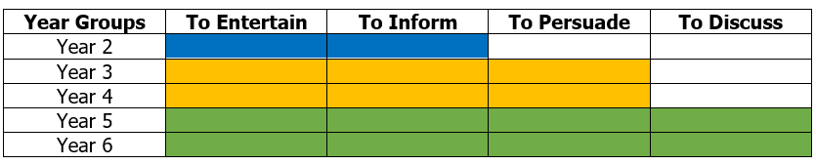
- When possible, give children explicit audience and purpose to write.
- Each year group to do at least two poetry units across the year.
- Jigsaws will be added to the beginning of children’s books to add to for every unit to show units that have been covered.

Medium Term Planning
Teachers to use the Medium Term planning template to plan their writing for the half term, saved in the One Drive.
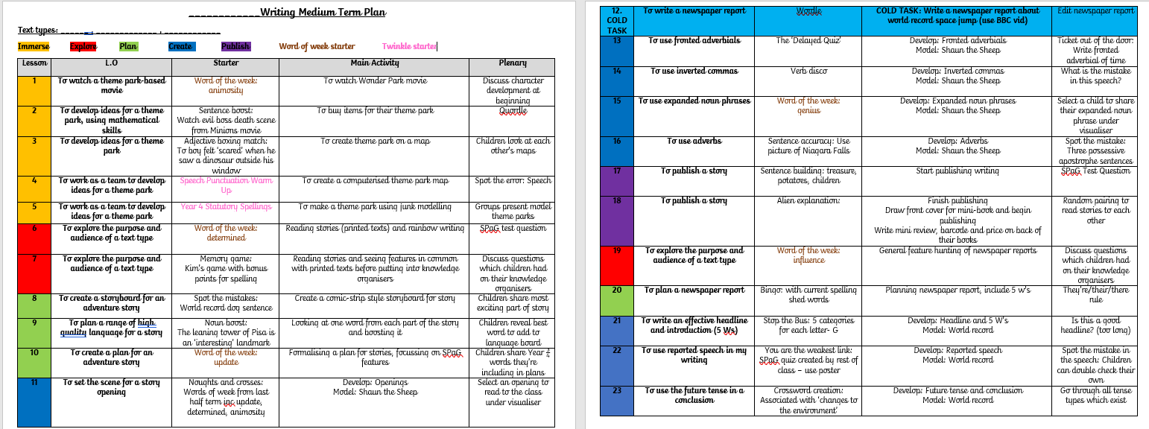

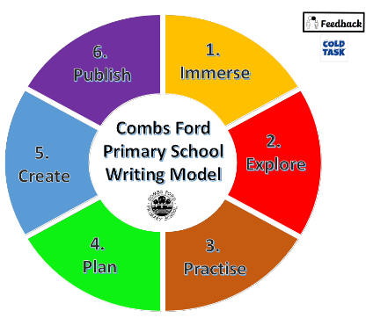
Lesson structure
- Every lesson to contain a starter and a plenary.
Starter: Needs to be engaging and get children into the ‘zone’ for being a writer, used as a recap or teaching opportunity.
Plenary: Used as an opportunity to round-off the lesson or to attempt something like a SPaG test question example.
- Once every five lessons, the lesson starter needs to introduce the children’s Word of the Week (linked to the curriculum). Use this vocabulary in other starters in fun engaging ways in a range of contexts to help embed meaning.

Cold Task
- At the beginning of a unit, children to be given a cold task to attempt for the text type.
- The stimulus for the cold task needs to be engaging yet simple to understand (reducing cognitive load) for pupils.
- The theme for the cold task needs to be an entirely different context to the theme of their final independent write as it will be the basis of the teachers’ model writing in the Create step.

Step 1: Immerse
- 1-2 lessons at the beginning of a unit to support the text type focus. Activities chosen need to be selected carefully to enhance the children’s opportunity to engage with vocabulary and knowledge that will directly help them with their writing.
- Children to stick a sheet in books which summarises theme for writing and immersion for the half term (example below).
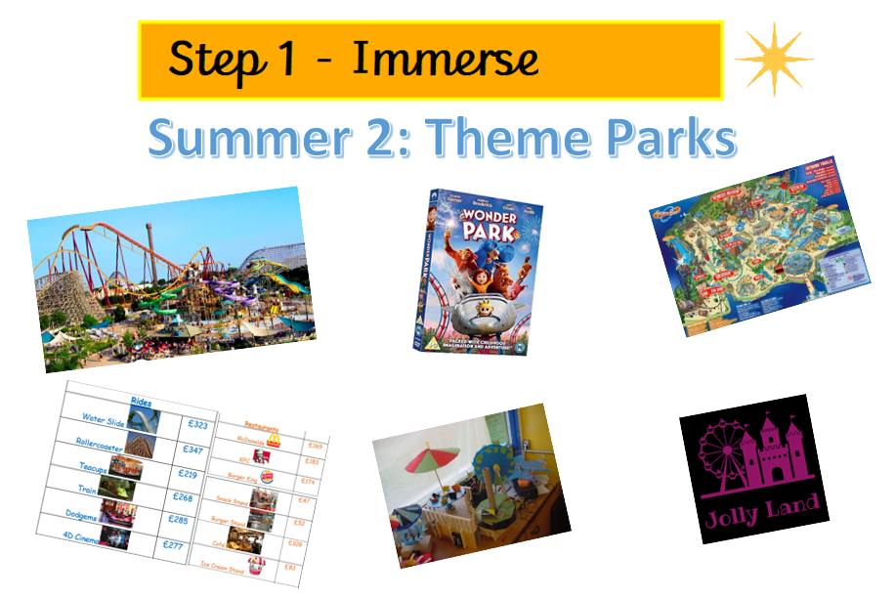
- Take photos of the immersion and save in the relevant folder on the One Drive to showcase our school’s writing curriculum on the school website.
- Immersion step to include opportunities for the development of speaking and listening skills through debate, role play, improvisations, performances and discussion.

Step 2: Explore
- 2 lessons first teaching SPaG features explicitly but then in context. Create meaningful connections rather than stand-alone unlinked grammar here.
- 1 or 2 lessons unpicking and exploring example texts with evidence of taught punctuation and grammar
- Expose children to at least two different examples (one of which could be modelled on the board) for children to experience a broader range of the text type.
- Where possible, try to use a varied range of examples from printed examples (Twinkl, Literacy Shed, AI creations etc) and books from the library whenever possible that has examples of the taught SPaG.
- Where appropriate, find the opportunity for rainbow writing, using the colour poster for their year group.
- Children finish this step creating their own knowledge organiser, as a class for working wall display.
- LO with Success criteria to be used where appropriate following the checklist format already used in the ‘Plan’ and ‘Create’ stage. SPaG specific checklist to be used for SPaG lessons.

Step 3: Practise
- 3 lessons selecting an element or two from the text type to practise writing in the style of.
- Ensure the children are practising using a brand new context.
- Children may use whiteboards to draft but are still expected to write their work up in their books.
- LO with Success criteria to be used where appropriate following the checklist format already used in the ‘Plan’ and ‘Create’ stage as well as SPaG features for the year group.

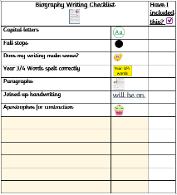
Step 4: Plan
- 1 to 2 lessons, depending on the text type (independent research may be required for some).
- Share with children the PAT (purpose, audience, text type).
- Take a format that children find useful, focusing on planning less, but using what they plan.
- Allow children an appropriate balance of freedom and rigidity.
- As a class, agree on what needs to go into the writing checklist, using the understanding of the conventions and features of the text type uncovered in the Explore step (example to the right).

Step 5: Create
- Follow the 5 stages for the create step but in manageable steps (see MTP):
  - Develop: Teach the focus of this lesson and allow children the opportunity to independently practice – this does not have to involve using a worksheet.
  - Model: Using the context provided in the cold task, teachers to model how to write a high level version of the text type on flipchart paper, children to look at their cold tasks and compare the difference. Teachers to display the flipchart paper example, to build up a model text across each day pf the Create step.
  - Draft: Children to have the appropriate amount of time to independently draft their own writing, with access to their plans, checklists, dictionaries, thesauruses and help cards.
  - Share: Children will swap work with a partner and provide each other with feedback.
  - Edit: Children will be given time to edit their work and correct mistakes.
- Children to stick in their writing checklists at the beginning of this step.
- In the following Create lessons, allow time at the beginning of the next lesson for DIRT (Dedicated Improvement and Reflection Time) to respond to triangle marking from the previous lesson.

Step 6: Publish
- Children to use neatest writing to produce a top copy of their draft from the Create step
- Once published and if time allows, children can use rulers and coloured pencils to look for evidence of SPaG features from Rainbow writing lists and underline in books to see how many times they have been used.
- All published work to be displayed in areas (see below).
- Once completed, put work up on the wall in the area and stick the older piece from the wall into their writing journey books.

Feedback Lesson
- Once within each unit, one lesson to allow the teacher to provide verbal feedback to the children with their tracked write and post-it note. Children to keep targets in their book.
- During the lesson, children complete independent tasks without teacher support.

Tracking Writing
- Teachers to track each published piece of writing for every child, using the school’s writing trackers.
- In their folders, teachers need to list the text type plus the date relating to that piece of writing (not ticking off).
- UKS2 will have trackers accessible to children.

Display
Each class in Year 3 onwards needs three displays for writing:
- Writing Working Wall: Inside the classroom, a writing working wall will need to display the five steps of the model, examples of the text types you have looked at during the Explore step, the ‘hook’ that was used to engage the pupils, the model text created in the Create step and any summary sheets created when teaching Spelling, Punctuation and Grammar features.
- Word of the Week: Displaying the Words of the Week
- Published Writing: A display to showcase all of the children’s published work from the previous unit outside of classrooms.

Marking and Feedback
See ‘Feedback for Marking and Writing Policy’ on the One Drive

Flexi-Time
- Year 1 and above will incorporate additional SPaG as well as their normal handwriting sessions into their week.
- KS2 will have 5 writing flexi sessions over the week made up of spellings, handwriting and PaG.
- SPaG focus will be based on the MTP that can be found on One Drive and any gap analysis from the Subject lead must be included in these sessions or during lesson introductions.
- SPaG sessions to use dictation to allow children to focus on transcription skills to identify how to move children forward.

Handwriting
The school will follow the Penpals scheme for handwriting from EYFS to Year 6 using their supporting interactive software. The teaching of handwriting will be carried out through discrete teaching and practise, Twinkl Phonics lessons and revision of skills during writing lessons and flexi sessions.
- From Year 1, all handwriting practise will be carried out in handwriting books.
- Year 1 - 6 will teach 1 x session of discrete handwriting teaching per week
- Year 1-6 will allow additional writing practise time in writing lessons and early morning work weekly.

