Grammar Long Term Plan Year 5

Statutory Requirements for Year 5 and 6 | 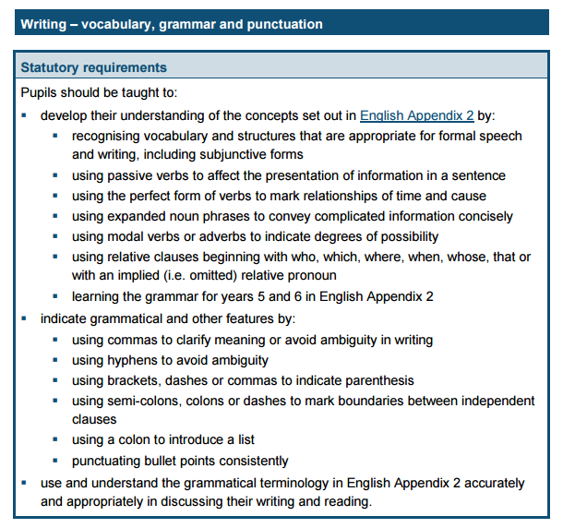

Term | Coverage | Examples and Activities
Autumn  1 | Revision of year 3/4 Grammar (Targets 1-18)  Week 1: Revise word classes from previous year and KS1. What is a noun? What is a noun phrase? What is an adjective? What is a preposition? What is a determiner?  Week 2: Revise word classes from previous year and KS1.What is a pronoun? What is a possessive pronoun? What is a verb? What is an adverb?  Week 3 : Revise verb tenses – simple past and simple present, present perfect and present progressive. What is the present perfect tense? What is the progressive tense? (Year 2) Ensure understanding of the key terms. Include different tense verbs – present, past, progressive and past perfect.  Week 4: Revise simple sentence. Write simple sentences in various verb forms using noun phrases, prepositions to add interest. Identify the single action and revise the fact that there is only one main clause in these sentences so therefore no conjunction. Assess understanding of noun phrases, prepositions and use of punctuation.  Week 5: Revise the term conjunction. Identifying the conjunction in compound sentences. Teach that using conjunction will create a multi-clause sentence. FANBOYS. Revise compound sentence.  Week 6 : Revise conjunctions in complex sentences – identify the complex sentence. Identify the subordinating conjunction.  Note - Week 4-6 is a revision of sentence types | Week 1 Play games involving understanding of word classes – noun, verb, adjective, , preposition. Could be find the word class in a sentence – sentence detective style game or simply a word sort. Sort words in: the Roman book on the shelf  Week 2 As per week one but with focus on other word classes.  Week 3  Write and identify range of tenses in the different forms. May need extra week for this at a later date.  Week 4 Use words from spelling plans to write sentences with different verb forms, expanded noun phrases, simple single clause sentences.  Week 5 At this point, focus on identifying the conjunction in compound sentence, Teach FANBOYS and equal weighting clause sentence.  Teach they will come in middle of the clauses.  Week 6 Focus on the complex sentence rules; revise the subordinate clause; find the subordinate conjunction – teach they will come at the beginning or in the middle of the sentence.
Autumn  2 | Week 1 : Revise Noun types - proper, common, collective  NEW - teach abstract nouns.  Week 2 Revise command, statement, question or exclamation. Identify the sentence type; use the correct punctuation  .  Week 3: NEW Modal verbs– I can indicate degrees of possibility using adverbs e.g. perhaps, surely and modal verbs e.g. might, should will, must.  Week 4 : NEW Relative Pronouns I can use and identify relative pronouns and relative clauses starting with: who, which, when, whose, that.  Week 5 : Revision - Commas Revise commas in lists, fronted adverbials .  Week 6 NEW Commas I can use commas to clarify meaning and avoid ambiguity in writing. | Week 1: Different noun types proper, collective, abstract and common to sort and investigate.  My birthday is in November.  I found a herd of lions when I went on safari.  Ipswich, November, cat, pencil, flock, swarm etc  Week 2: When do we use each sentence type? Which punctuation is used when?  Week: 3: Modal Verbs. Write sentences using different modal verbs. Which modal verbs indicate possibility? Which indicate certainty?  Week 4 What is a relative pronoun? Find the relative pronoun (in red) and then the relative clause (underlined)  Joe is the man who delivers the milk.  I prefer the blue shoes, which match my dress.  The girl who knocked on the door ran away.  Week 5 When do you use a comma? Revise commas in lists; commas after fronted adverbials,  Week 6: You will need to cover the following :  - Commas after subordinate clauses  - Commas in pairs for extra information ( will cover again in parenthesis)  - Commas to clarify meaning eg.. Let’s eat, Grandad V Let’s eat Grandad.  - The comma splice – how the comma does not replace a full stop.
Spring  1 | Week 1: Revision of punctuation I can punctuate my sentences correctly with capital letters, full-stops, question marks, exclamation marks, commas, apostrophes,  Week 2 : Revision of punctuation I can punctuate my sentences correctly with capital letters, full-stops, question marks, exclamation marks, commas, apostrophes,  Week 3 : Revision of sentence structure I can vary length and structure of my sentences by using different types of sentence.  Week 4 : NEW Paragraph cohesion I can use devices to build cohesion within a paragraph e.g then, after that, firstly.  Week 5 : Revise Speech  Revise the terms ‘direct speech’ and ‘inverted commas’ Teach use of the comma with speech  NEW : Using split speech  Week 6 : Revise Proofreading with focus on speech, verbs and tenses matching  Can you spot mistakes? E.g. I did, not I done. See Year 4 Spring Term 2 Week 4 | Week 1: Proof Reading punctuation – from a pre-prepared passage, children to find and correct punctuation errors. This can help assess lesson required the following week. Focus on CL, FS, ! ?  Week 2: Editing/proof reading for commas in particular.  Week 3 - Challenge pupils to write different kinds of sentence. Simple, Compound (FANBOYS) and Complex (subordinating clauses) Recap clauses through activities e.g..  Find the conjunction game. Is it FANBOYS? e.g.  I was afraid of spiders yet I picked one up.  Underline the subordinate clause activities. E.g.  Although it was raining, I went outside.  Find the main clauses. Although it was raining, I went outside.  Week 4: Explain/teach how to link ideas in a paragraph using adverbials.  Week 5 : Revise speech and punctuation in single speech sentences e.g. “It is a lovely day,” said Mum.  Mum said, “It’s a lovely day.”  Teach the split speech “Look,” said Amy, “it’s up there!”  Week 6 : Provide opportunities for children to find mistakes – in speech, verb tenses etc Use it to assess understanding of coverage to date.  Proof read and correct errors in verbs e.g.  Today I jumps over the wall.  Last night, I eaten a banana.  They walks to the park.
Spring  2 | Week 1 : Revise apostrophes Revise for omission, possession, Include term contraction. (See weeks 1-3 Year 4 Spring 2)  Week 2 : New Understanding when to use the apostrophe with it’s v its  Week 3 : New : Parenthesis. I can use parenthesis – brackets, dashes and commas for the same purpose.  Week 4 : Revise term conjunction NEW Use the term co-ordinating conjunction for the FANBOYS and the term subordinating conjunction. Include the relative pronoun and relative clause  Week 5 : New Using adverbials of time, manner, place, number to link ideas across paragraphs.  Week 6 : Revision of clauses v phrases.  What is a clause? What is a phrase?  Suggested Grammar display focus :  Using Parenthesis  Do you know when to use brackets, dashes and commas for parenthesis? | Week 1: Review the apostrophe for omission/contraction  cannot / can’t won’t /will not I will / I’ll Revise the use of apostrophe for possession – single nouns e.g. the girl’s hat Sarah’s house  Week 2 : Ensure that children understand the difference and go through range of examples to highlight difference CGP Year 5 Target Book p59  Week 3 : Teach the use of this for extra information and the term parenthesis CGP p52-55  Week 4 : Range of activities relating to conjunction types – both sentence types  Week 5 : Discuss where these can go and how they can add more to a sentence and then a paragraph  Week 6 : Underline the clause; Underline the phrase etc
Summer  1 | Week 1: Revise term pronoun, possessive pronouns from Autumn 1.  Week 2 : NEW I can change nouns into verbs by adding suffixes such as –ate, -ise, ify.  Week 3 : NEW I can change adjectives into verbs by adding suffixes such as –ate, -ise, ify.  Week 4 : Revise  Spot the sentence types  - simple – no conjunction  - compound - FANBOYS conjunction  - complex - subordinating clause and conjunction  Can discuss the terms simple, compound and complex. Although these terms are not statutory, they are useful to know.  Week 5 & 6 : Word class challenges  Find the verb, noun, adjective, adverb, preposition, pronoun, determiner, relative pronoun and conjunction in sentences.  Suggested Grammar display focus : Changing word classes by adding suffixes | Week 1: Sentence level activities and games.  Week 2: Games involving how word classes can change  Week 3 As week 2  Week4 : Sorting based games. Give range of sentence types. Find the conjunction – if there is one, find the clause - Is it a FANBOYS conjunction and or can they find a subordinate clause.  Week 5/6 : Game that involves identifying word classes. Make up sentences or word cards to sort.
Summer  2 | The remainder of the term will be revision based on teacher assessment.  Please re-visit any area necessary and plan a range of activities based on these requirements. | Revise Putting it altogether in compound and complex sentences- Writing sentences that include collective nouns, adjectives, adverbs, prepositions, adverbials, conjunctions. Write in the simple past, simple present, progressive and the present perfect forms.

