Grammar Long Term Plan Year 4

Statutory Requirements for Year 4 | 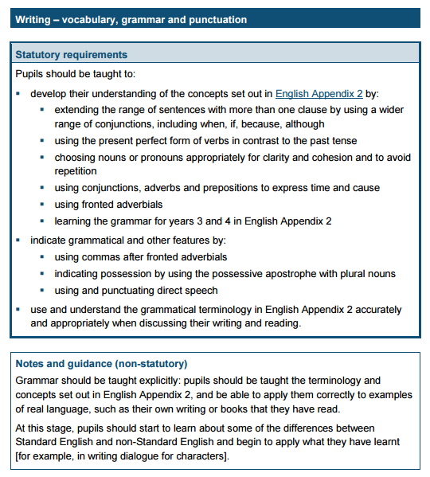

Term | Coverage | Examples and Activities
Autumn  1 | Revision of year 3 Grammar (Targets 1-18)  Week 1: Revise word classes from previous year and KS1. What is a noun? What is an adjective? What is a preposition? What is a verb? What is an adverb?  Week 2: Revise verb tenses – simple past and simple present, present perfect and present progressive. What is the present perfect tense? What is the progressive tense? (Year 2) Ensure understanding of the key terms. Include different tense verbs – present, past, progressive and past perfect.  Week 3: Proof reading for errors - Revise use of punctuation - capital letters, full stops, question marks, exclamation marks, speech marks.  Week 4: Revise and write simple sentences using noun phrases, prepositions to add interest. Identify the single action and revise the fact that there is only one main clause in these sentences so therefore no conjunction. Assess understanding of NP and Pre and use of punctuation.  Week 5: Revise the term conjunction. Identifying the conjunction in compound and complex sentences.  .  Week 6: Identify the sentence type –Revise command, statement, question or exclamation. | Week 1 Play games involving understanding of word classes – noun, verb, adjective, adverb, verb, preposition. Could be find the word class in a sentence – sentence detective style game or simply a word sort.  Week 2 Write and identify range of tenses in the different forms.  Week 3 Embed punctuation of CL and FS, ? comma in list, ! speech marks - Find errors in punctuation in sentences.  Week 4 Use words from spelling plans to write expanded noun phrases, simple and compound sentences. May have to revise term ‘noun phrase’.  Week 5 At this point, focus on identifying the conjunction rather than what sentence type it is or whether the conjunction is FANBOYS or subordinating.  Week 6 Children to write sentence types, which take the form of statements, commands, questions and exclamations.
Autumn  2 | Week 1 : Revise Noun types - proper and common as well.  NEW - teach collective nouns.  Week 2 NEW Determiners Part 1 What is a determiner?  Teach the basic determiners – a, an, the. Teach that they are found in front of nouns and/or adjectives. These determiners are called articles.  Week 3: NEW Determiners Part 2 – introduce further determiners such as numbers, quantity – one, some etc. Link it to noun work e.g. find the determiner and classify the noun type.  Week 4 : Sentence Openers Revise how to expand the simple single clause sentence with fronted adverbial phases linked to time.  New : Ensure correct use of the comma. Teach fronted adverbial phrases linked to place and manner.  Week 5 : Pronouns NEW- I can use a mixture of nouns and pronouns in my writing to avoid repetition and aid cohesion.  Week 6 : Revise Putting it altogether in compound and complex sentences- Writing sentences that include collective nouns, adjectives, adverbs, prepositions, adverbials, conjunctions. Write in the simple past, simple present, progressive and the present perfect forms. | Week 1: Different noun types proper, collective and common to sort and investigate.  My birthday is in November.  I found a herd of lions when I went on safari.  Ipswich, November, cat, pencil, flock, swarm etc  Week 2: Determiners – find the determiners in a sentence/paragraph of writing. e.g. The old man hobbled along a quiet street.  Week: 3: Determiners – find more determiners. Write sentences using different determiners. He bought two apples and several oranges. He didn’t have any money. Could link to other word classes as required.  Week 4 Fronted adverbial phrases linked to time, manner and place. Identify different types. Use comma correctly.  Last night, the cat sat on the mat behind the door.  With a grin, the boy picked up his bag.  Under the bridge, the animals sheltered from the storm.  Week 5 What is a pronoun? Discuss personal pronouns only – possessive coming later in the year.  Week 6: Write me a sentence that contains…noun phrases, prepositional phrase, adverbial relating to time.-eg  Last night, the ginger cat, sat quietly on the stripy mat behind the kitchen door.  Last night, the ginger cat, was sitting quietly on the stripy mat behind the kitchen door.  In the morning, the ginger cat, sits quietly on the stripy mat behind the kitchen door.  All day, the ginger cat, has sat quietly on the stripy mat behind the kitchen door.
Spring  1 | Week 1: Using paragraphs – What is a paragraph?  Week 2 : Revision What is a conjunction? Introduce the term conjunction and the FANBOYS conjunctions.  FOR/AND/NOR/BUT/OR/YET/SO  Week 3 : Revision Conjunctions – What is a subordinate clause?  Continue with conjunctions. Build on from previous week that with subordinating clauses, the clauses are not equal weighting and the subordinate relies on the main to make sense. What kind of clause is this?  Week 4 : Adjectives and prepositional phrases  Expand noun phrases with the addition of adjectives and prepositional phrases e.g. the teacher expanded to ‘the strict teacher with the curly hair  Week 5 : What are speech marks?  Revise the terms ‘direct speech’ and ‘inverted commas’ Teach use of the comma with speech  Week 6 : Proofreading  Can you spot mistakes?  Suggested Grammar display focus : Conjunctions  Do you know your conjunctions and clauses?  Add speech marks to your punctuation display. | Week 1: Sort writing into paragraphs. Investigate opening words that introduce a paragraph. Find the paragraph theme.  Week 2: Revisit ‘joining words’ from Year 2 and introduce correct term conjunction. Explain that 7 of these make up compound sentences i.e- two equal weighting sentences with 2 main clauses. Each clause is of the same importance.  Write sentences using these. No statutory requirement to use the term co-ordinating conjunction in Year 3. No expectation for them to remember all of these in Year 3. Teach that these words do not come at the start of the sentence.  Week 3 Play games identifying the subordinate clause – no need to focus on the use of the comma if SC comes first but can mention it. Focus on common SC – although, because, when, if, while. Teach that these conjunctions can come at the start of a sentence as well as in the middle of the two clauses.  Week 4 Recap clauses through activities e.g..  Find the conjunction game. Is it FANBOYS? e.g.  I was afraid of spiders yet I picked one up.  Underline the subordinate clause activities. E.g.  Although it was raining, I went outside.  Find the main clauses. Although it was raining, I went outside.  Week 5 : Introduction to speech.. Identify the speech marks and write single speech sentences e.g.  “It is a lovely day,” said Mum.  Mum said, “It’s a lovely day.”  Teach the use of the comma  Teach the use of the capital letter if speaker comes first.  Week 6 : Provide opportunities for children to find mistakes – in speech, CL, FS, ? etc Use it to assess understanding of coverage to date.
Spring  2 | Week 1 : What is an apostrophe?  Revise for omission. Can use the term contraction.  Week 2 : Revision How do you use an apostrophe to show possession of something?  New : Plural possession use apostrophes to mark plural possession e.g. the girl’s name and the girls’ names  Week 3 : I can explain the difference between the plural s and the possessive s. boys and boy’s and boys’  Week 4 : New - I can use the correct form of the verb e.g. we were instead of we was or I did instead of I done  Week 5 : Revision Putting it altogether in simple, compound and complex sentences- Writing that include collective nouns, adjectives, adverbs, prepositions, adverbials. Write in the simple past, simple present, progressive and the present perfect forms. Include sentences with apostrophes.  Week 6 : Proofreading  Can you spot mistakes? | Week 1: Review the apostrophe for omission/contraction  cannot / can’t won’t /will not I will / I’ll  Week 2 Revise the use of apostrophe for possession – single nouns e.g. the girl’s hat Sarah’s house  Week 2: Explain use of plural and the plural apostrophe  The boys like to play football. – No possession  The boy’s bike is green. – Belong to one boy  The boys’ bikes are green. – Belong to several boys  Week 3 Revise the use of apostrophe for possession – single nouns e.g. the girl’s hat Sarah’s house  Week 4 Proof read and correct errors in verbs e.g.  Today I jumps over the wall.  Last night, I eaten a banana.  They walks to the park.  Week 5 : Group words into word families based on common words Solve, solution, dissolve  Week 6 : Provide opportunities for children to find mistakes – in speech, CL, FS, ? etc Use it to assess understanding of coverage to date.
Summer  1 | Week 1: Revise term pronoun from Autumn 2.  NEW T9 : I can identify and use possessive pronouns in my writing.  Week 2 : Revise Starting sentences with adverbials.  Using the comma after an adverbial.  Week 3 : Proof Reading –punctuation errors  Week 4 : Revise  Spot the sentence types  - simple – no conjunction  - compound - FANBOYS conjunction  - complex - subordinating clause and conjunction  Can discuss the terms simple, compound and complex. Although these terms are not statutory, they are useful to know.  Week 5 : Word class challenge  Find the verb, noun, adjective, adverb and conjunction in sentences. | Week 1: Teach using the -ing clause to start a sentence. Looking ahead, I spotted my best friend. Give list of verbs that children can use to start their sentences.  Week 2: Revise time adverbials as phrases and focussed teaching of using the comma.  Week 3 Proof read and correct errors in punctuation e.g..  sam lives in ipswich he likes to play football his favourite food is burgers especially from burger king  Week4 : Sorting based games. Give range of sentence types. Find the conjunction – if there is one, find the clause - Is it a FANBOYS conjunction and or can they find a subordinate clause.  Week 5 : Game that involves identifying word classes. Make up sentences or word cards to sort.
Summer  2 | The remainder of the term will be revision based on teacher assessment.  Please re-visit any area necessary and plan a range of activities based on these requirements. | Week 1 : Create new words using a range of prefixes – super, auto, anti. Discuss if word class changes.

