Grammar Long Term Plan Year 3

Statutory Requirements for Year 3 and 4 | 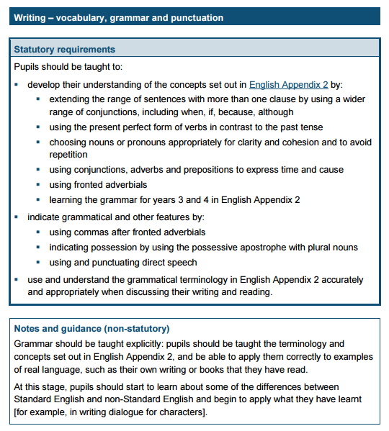

Term | Coverage | Examples and Activities
Autumn  1 | Revision of year 2 Grammar  Week 1: Simple sentence writing highlighting verb/noun/adjective. (Importance of full stop/capital letter). What is a noun? What is a verb? What is an adjective? Ensure understanding of the key terms.  Week 2: Simple sentence with an adverb – ly adverbs only (Also comes up again in Week 11 of spelling – adding –ly) What is an adverb?  Week 3: Write and identify noun phrases and use commas in a list.  Week 4: Verbs simple past and simple present; present and past progressive.  Week 5: Compound sentences adding simple conjunctions – and, so, but  .  Week 6: Sentence types correctly punctuated. Exclamation, statement, question and command. | Play games involving understanding of word classes – noun, verb, adjective, adverb.  Embed punctuation of CL and FS, ? comma in list, !  Use words from spelling plans to write expanded noun phrases, simple and compound sentences.  Children to write sentence types, which take the form of statements, commands, questions and exclamations.
Suggested Grammar and Punctuation Working Wall Display
Do you know your word classes? : Nouns, adjectives, sentence forms – statement, question mark, exclamation mark, commands
Punctuation Display : . ! ?
Autumn  2 | Week 1 : New Noun types – identify and use terms common and proper nouns Write expanded noun phrases using these nouns. Highlight the need for the CL with the proper noun.  Week 2 NEW What is a clause?  - To understand that a clause includes a verb which makes it a sentence. The old dog barked… as opposed to the phrase the old dog  - To understand that if it has one verb, then it has one clause i.e. one thing happening in it.  - Focus on main clause sentences only.  - Refer to these as simple sentences – only one action in the sentence.  - Can remind pupils that phrases e.g. noun phrases do not include verbs and therefore cannot make a sentence on their own.  Week 3: Verbs – revise simple tense and progressive formats – NEW introduce the present perfect tense in simple sentences only.  Week 4 : NEW Introduce the term preposition and write sentences with one clause that are still simple but include more detail because of the prepositional information.  Week 5 : NEW How to expand the simple single clause sentence with adverbs or adverbial phases linked to time Will be revisited in the summer term with extra focus on adding the comma.  Week 6 : Revise putting it altogether - Writing detailed but simple sentences that include adjectives, adverbs, prepositions, time adverbials. Write in the simple past, simple present, progressive and the present perfect forms. | Week 1: Different noun types proper and common.  My birthday is in November.  I found my cat at Ipswich train station.  Ipswich, November, cat, pencil, door  Week 2: Clause understanding – can pupils find the verb? Can they find the action in the sentence to make it a main clause?  Week: 3: e.g. Verbs simple past tense moving to present perfect. Write main clause sentences in the present perfect.  I wrote an adventure story.  I have written an adventure story.  Week 4: Preposition, with a single clause.  The cat sat behind the door.  The cat sat on the mat behind the door.  Week 5 Clauses with adverbial phrases linked to time.  Last night, the cat sat on the mat behind the door. Next, the cat stretched out on the rug.  Week 6: Sentences with noun phrases, prepositional phrase, adverbial relating to time.-eg  Last night, the ginger cat, sat quietly on the stripy mat behind the kitchen door.  Last night, the ginger cat, was sitting quietly on the stripy mat behind the kitchen door.  In the morning, the ginger cat, sits quietly on the stripy mat behind the kitchen door.  All day, the ginger cat, has sat quietly on the stripy mat behind the kitchen door.
Spring  1 | Week 1: NEW Using paragraphs – What is a paragraph?  Week 2 : NEW What is a conjunction? Introduce the term conjunction and the FANBOYS conjunctions.  FOR/AND/NOR/BUT/OR/YET/SO  Week 3 : NEW Conjunctions – What is a subordinate clause?  Continue with conjunctions. Build on from previous week that with subordinating clauses, the clauses are not equal weighting and the subordinate relies on the main to make sense.  Week 4 : REVISE What kind of clause is this?  Revise clause types – main and subordinate.  Week 5 : NEW What are speech marks?  Cover the terms ‘direct speech’ and ‘inverted commas’ Expectation is to know where to put the speech marks.  Week 6 : Revise through Proofreading  Can you spot mistakes?  Suggested Grammar display focus : Conjunctions  Do you know your conjunctions and clauses?  Add speech marks to your punctuation display. | Week 1: Sort writing into paragraphs. Investigate opening words that introduce a paragraph. Find the paragraph theme.  Week 2: Revisit ‘joining words’ from Year 2 and introduce correct term conjunction. Explain that 7 of these make up compound sentences i.e- two equal weighting sentences with 2 main clauses. Each clause is of the same importance.  Write sentences using these. No statutory requirement to use the term co-ordinating conjunction in Year 3. No expectation for them to remember all of these in Year 3. Teach that these words do not come at the start of the sentence.  Week 3 Play games identifying the subordinate clause – no need to focus on the use of the comma if SC comes first but can mention it. Focus on common SC – although, because, when, if, while. Teach that these conjunctions can come at the start of a sentence as well as in the middle of the two clauses.  Week 4 Recap clauses through activities e.g..  Find the conjunction game. Is it FANBOYS? e.g.  I was afraid of spiders yet I picked one up.  Underline the subordinate clause activities. E.g.  Although it was raining, I went outside.  Find the main clauses. Although it was raining, I went outside.  Week 5 : Introduction to speech.. Identify the speech marks and write single speech sentences e.g.  “It is a lovely day,” said Mum.  Mum said, “It’s a lovely day.”  Teach where the speech marks have to go. The use of the comma and capital letter if speaker comes first will be a focus in Yr 4.  Week 6 : Provide opportunities for children to find mistakes – in speech, CL, FS, ? etc Use it to assess understanding of coverage to date.
Spring  2 | Week 1: NEW Using ‘a’ and ‘an’ – What is a consonant? What is a vowel?  Week 2: NEW What is a powerful verb?  Week 3 : REVISE What is an apostrophe?  Revise for omission. Can use the term contraction.  Week 4 : REVISE How do you use an apostrophe to show possession of something?  Week 5 : REVISE Proof Reading –recognition of wrong verb tense  Week 6 : NEW What is a word family?  Links to spelling plan weeks 23/24  Suggested Grammar display focus :  Using the apostrophe  Do you know when to use an apostrophe?  Link in the ‘a’ and ‘an’ rule. | Week 1 : List of words – find vowels, find consonants, decide which one uses an and which use a. Discuss when/where an/a used ie before a noun. Other words before a noun – the, some etc. .  Week 2: Finding alternatives for said/look/eat etc.  whispered, shouted munched nibbled, stared, peeked  Week 3: Review the apostrophe for omission/contraction  cannot / can’t won’t /will not I will / I’ll  Week 4 Revise the use of apostrophe for possession – single nouns e.g. the girl’s hat Sarah’s house  Week 5 Proof read and correct errors in verbs e.g.  Today I jumps over the wall.  Last night, I eaten a banana.  They walks to the park.  Week 6 : Group words into word families based on common words Solve, solution, dissolve
Summer  1 | All target areas now covered so summer term will therefore focus on: writing sentences using a range of different starters and revision.  Week 1: Revise Starting sentences with –ing verbs.  Week 2 : Revise Starting sentences with – time adverbials.  Using the comma after a time adverbial.  Week 3 : Revise Proof Reading –punctuation errors  Week 4 : Revise Spot the sentence types  - simple – no conjunction  - compound - FANBOYS conjunction  - complex - subordinating clause and conjunction  Can discuss the terms simple, compound and complex. Although they are not statutory, they are useful to know.  Week 5 : Revise - Word class challenge  Find the verb, noun, adjective, adverb and conjunction in sentences.  Week 6 : NEW Using prefixes to create new words Linked to spelling revision for Year 3 but also a grammar requirement. Does the word class change?  Suggested Grammar display focus :  Sentence Types  What is a simple sentence?  What is a compound sentence?  What is a complex sentence? | Week 1: Teach using the -ing clause to start a sentence. Looking ahead, I spotted my best friend. Give list of verbs that children can use to start their sentences.  Week 2: Revise time adverbials as phrases and focussed teaching of using the comma.  Week 3 Proof read and correct errors in punctuation e.g..  sam lives in ipswich he likes to play football his favourite food is burgers especially from burger king  Week4 : Sorting based games. Give range of sentence types. Find the conjunction – if there is one, find the clause - Is it a FANBOYS conjunction and or can they find a subordinate clause.  Week 5 : Game that involves identifying word classes. Make up sentences or word cards to sort.  Week 6 : Create new words using a range of prefixes – super, auto, anti. Discuss if word class changes.
Summer  2 | The remainder of the term will be revision based on teacher assessment.  Please re-visit any area necessary and plan a range of activities based on these requirements.

