Grammar Long Term Plan Year 6

Statutory Requirements for Year 5 and 6 | 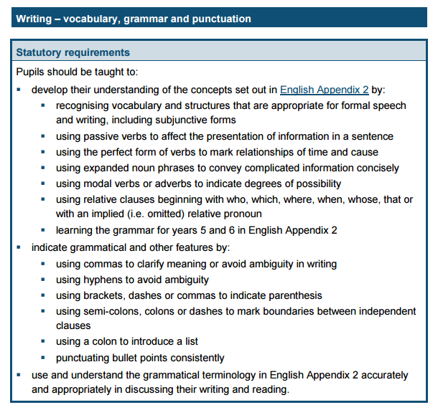

Term | Coverage | Examples and Activities
Autumn  1 | Week 1: Revise word classes from previous year and KS1. What is a noun? What is an adjective?  Week 2: Revise word classes from previous year and KS1. What is a verb? What is an adverb?  Week 3: Revise term adverbial  What is phrase? Adverbial phrases relating to time, manner and place  Must be able to identify the difference between clause and phrase.  Week 4: Revise term preposition What is a preposition?  Week 5: Revise term pronoun What is a pronoun? What is a possessive pronoun?  Week 6: Revise the term determiner. What is a determiner? | Week 1 Introduce the glossary sheet of key terms  - Play game involving grammatical terms  - Discuss the function of nouns in sentences  - Review types of nouns including abstract and collective.  - Noun detective game  - Adjectives revision  Week 2 Function of a verb  - Verb tenses – simple present, future, past  - Identifying the verb(s) in a sentence  - Relationship between verb and adverb  - See Spring term for more verb work  Week 3 What is a phrase?  - Types – noun phrase, adjectival phrase and adverbial phrase  - Identifying different types of phrases  - Write a range of different phrases  Week 4 Function of a preposition  - Identifying prepositions within a sentence  - Able to give a definition  - Relationship between adverb and preposition and identifying which is which in a sentence.  Week 5 Function of a pronoun  - Types of pronoun – personal, possessive  - Relationship between nouns and pronouns  Week 6 Function of a determiner.  - Identify different forms of determiners  - Write sentences using different determiners.  - Make links to other word classes – where do determiners go in relation to other word classes?
Suggested Grammar and Punctuation Working Wall Display
Do you know your word classes? Nouns, adjectives, adverbs, verbs, prepositions, sentence forms – statement, question mark, exclamation mark, commands; Verb tenses - progressive; Punctuation Display : . ! ? “ ” ’
Autumn  2 | Week 1 : Revise general - Statements, Questions, Commands and Exclamations.  NEW - Question tags; Word order for commands; Exclamation starters.  Week 2 Revise - What is the difference between a clause and a phrase? What is a clause? What is a phrase? Revise the noun phrase  Revise term – simple or single clause sentence  .  Week 3: Revise – Multi-clause sentences  What is a multi-clause sentence? What is a conjunction? Revise term conjunction and the FANBOYS conjunctions known as co-ordinating conjunctions. FOR/AND/NOR/BUT/OR/YET/SO  Week 4 : Revise Subordinating conjunctions and subordinate clauses.  Week 5 : Revise relative clauses with relative pronouns – who, where, when, whose, that, which  Week 6 : Revise Putting it altogether in compound and complex sentences- Writing sentences that include range of conjunctions. | Week 1: Commands, Statements, Questions and Exclamations  - Review how the grammatical structure in a sentence determines sentence type.  - Teach the question tag; teach how exclamations start with what or how;  - Teach how commands don’t always start with an imperative verb and that if phrases/clauses can be swapped around, it can still be a command.  e.g. Before you go out, lock the door. Lock the door before you go out.  Week 2: Clauses and Phrases  - Children must be able to understand the difference between a clause and a phrase. i.e. phrase has no verb; Lots of examples of identifying phrases V clause  - Revise the noun phrase – what is the longest noun phrase you can have e.g. the wooden shed at the end of the garden  Week: 3: Co-ordinating Conjunctions  - To understand why a sentence is compound i.e. equal weighted clauses  - These conjunctions always come in the middle ie. You cannot start a sentence with a co-ordinating conjunctions  - Write sentences with FANBOYS conjunctions.  Week 4 Subordinating conjunctions and clauses  - Continue with conjunctions. Build on from previous week that with subordinating clauses, the clauses are not equal weighting and the subordinate relies on the main to make sense.  Week 5 Relative pronouns and relative clauses  - What is a relative pronoun? Find the relative pronoun (in red) and then the relative clause (underlined)  I prefer the blue shoes, which match my dress.  The girl who knocked on the door ran away.  Week 6: Sentence Types  - Write me a compound/complex sentence that contains…noun phrases, prepositional phrase, adverbial relating to time.-eg  The ginger cat sat quietly on the stripy mat behind the kitchen door and stared at the mouse.  - The ginger cat, which lived next door, got stuck up a tree.  - Joe is the man who delivers the milk.
Spring  1 | Week 1: Revise simple past and simple present and progressive form  Week 2 : Revise verbs in the perfect form  Week 3 : Revise verbs in the modal form.  Week 4 : NEW: Subject and Object; Active and Passive voice  Week 5 : NEW Formal and Informal vocabulary  The subjunctive form; formal v informal  Content Domain G6 : Vocabulary  Week 6 : NEW Synonyms and Antonyms | Week 1: Simple Past, Simple Present, Progressive Forms  - Identify different forms – which tense is needed when  - Identify the verbs used in the progressive form  Week 2: The Perfect Form  - Identify the perfect form and when to use it.  - See Year 3 plans for more info.  Week 3 Modal Verbs  - Write sentences using different modal verbs. Which modal verbs indicate possibility? Which indicate certainty?  Week 4 Subject and Object; Active and Passive  - Identify the subject and the object in a sentence  - Make links to subject and object when identifying if a sentence is active and passive.  - Be able to change active sentence to passive and vice versa  Week 5 : Formal V Informal Vocabulary; subjunctive form  - Identify the subjunctive form in writing e.g. use of were  - Identify formal v informal vocabulary e.g. request v ask for  - Identify punctuation/structure with formal v informal e.g no use of exclamation mark in formal.  - Proof read and correct errors in verbs e.g.  Today I jumps over the wall. Last night, I eaten a banana.  They walks to the park.  Week 6 : Antonyms and Synonyms  - Identify what a synonym is.  - Identify what an antonym is.  - Find alternative synonyms when asked and change words to their antonym.
Spring  2 | Week 1 : Revise apostrophes  Week 2 : Revise commas  Week 3 : Revision speech marks  Week 4 : Revise punctuation for parenthesis  Week 5 : NEW : Colons and Semi-colons.  Week 6 : NEW : Single Dashes, Hypens, Bullet Points and Ellipses | Week 1: Apostrophes  - Review the apostrophe for omission/contraction  cannot / can’t won’t /will not I will / I’ll  - Revise the use of apostrophe for possession – single nouns e.g. the girl’s hat Sarah’s house  - Difference between the plural s and the possessive s. boys and boy’s  - Revise plural apostrophe doctor’s surgery V doctors’ surgery  Week 2: Commas – revise the following  - Commas in lists; after fronted adverbials  - Commas after subordinate clauses  - Commas in pairs for extra information ( will cover again in parenthesis)  - Commas to clarify meaning eg.. Let’s eat, Grandad V Let’s eat Grandad.  - The comma splice – how the comma does not replace a full stop.  Week 3 Speech Marks  - Revise speech and punctuation in single speech sentences e.g. “It is a lovely day,” said Mum.  Mum said, “It’s a lovely day.”  - Revise the split speech “Look,” said Amy, “it’s up there!”  Week 4 : Parenthesis  - Revise parenthesis – brackets, dashes and commas for the same purpose.  Week 5 : Colons and Semi-colons  - Use of colon in a list; between clauses to explain first clause  - Use of semi-colon – in lists; join equal weighted clauses  Week 6 : Single Dashes, Hyphens  - Difference between a dash and a hyphen  - Where and when to use the hyphen e.g. recovered/re-covered
Summer  1 | Week 1: Revision of WORD CLASSES  Week 2 : Revision of VERB TENSES and STANDARD ENGLISH based questions  Week 3 : Revision of CLAUSES and PHRASES  Revision of Sentence Types G  Week 4 : Revision of PUNCTUATION  Week 5 : SATS | - Use TestBase  - Complete past papers.
Summer  2 | After SATS, the remainder of the term will focus on writing tasks, with expectation being that writing shows firm grasp of the KS2 grammar skills.

