
Combs Ford Primary School
Glemsford Road
Stowmarket
Suffolk
IP14 2PN

Telephone: (01449) 613112

email: admin@combsfordprimary.co.uk
Headteacher: Mr Matt Wesley BA (Hons) MA PGCE NPQSL

Combs Ford Primary School News
Be the best that you can be!

Friday 5th June- Issue #34 | Weekly Attendance Winners:  Otters 98.7%
Happy Friday everyone! We hope you all had a wonderful half term!
  Combs Ford Running Club at Parkrun  On the first Sunday in half term, many children from our Running Club attended Junior Parkrun. This is a brilliant, free event held every Sunday at 9am at the Stowmarket Recreation Ground. Many children from the club were running 2km for the first time on that morning and they did such an amazing job! It was a beautiful but very hot morning to run so we were very thankful for the free ice pops! Thank you to the families and staff who came to support the event, we hope your children continue to enjoy it as part of their weekend routine! | 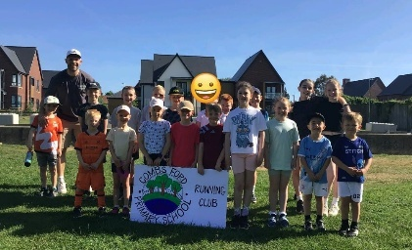  
Soccer Aid 2026  On Sunday at the end of half term, some of our KS2 children were fortunate enough to attend Soccer Aid 2026 for UNICEF. Mrs Ashton, Mr Wesley and Mrs Fullinger took a super group of 9 pupils on the train to Stratford to see the annual fundraising football match, comprising of ex footballers and celebrities. It was a sold-out capacity of 68,000 and was an incredible atmosphere. The event itself raised an amazing £18,500,000 for UNICEF! The children had a wonderful time and were a credit to the school! | 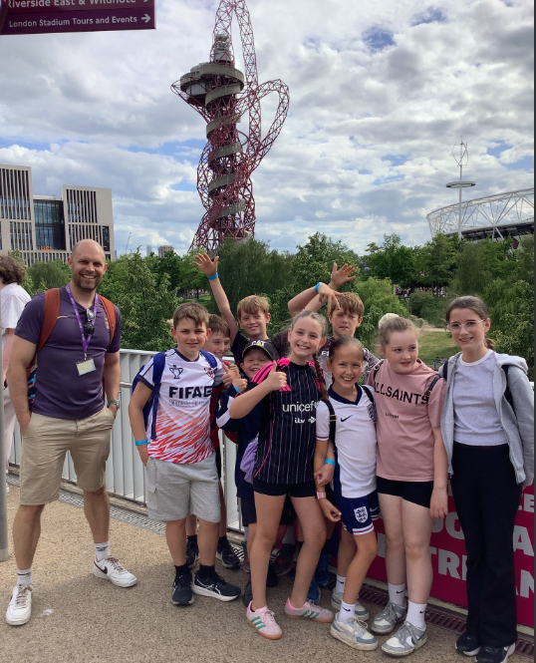
Year 4’s Art Project!  We were very proud to see that some of Year 4’s still life art project from last half-term has gone up on display at the Ipswich Waterfront. If you’re ever in the area by the Dance East building on the quay, feel free to pop in and have a look! Great work, Year 4! | 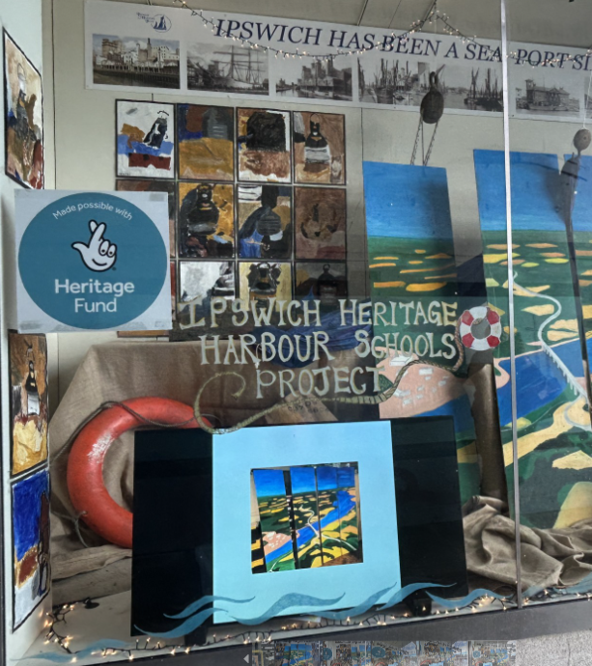
Year 5/6 Cricket Champions!  Congratulation to our Year 5 and 6 cricket team who delivered outstanding performances to win both of their matches at the GVTSSP finals held at Woolpit Cricket Club. We are incredibly proud of their achievement in bringing home the gold 🥇Their dedication in training, excellent teamwork and positive attitude were evident throughout the competition. They represented our school brilliantly and showed fantastic sportsmanship. | 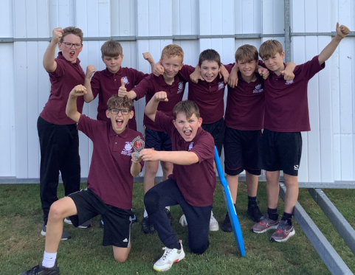
Year 6 Storytelling Workshop  On Tuesday and Thursday, Year 6 were joined by Dan from Chapter 82, who ran a storytelling workshop with them. He told them lots of stories and the children then created a storyboard of one of them before trying to retell it to another group. They've also created a range of amazing story starters that will hopefully be published in a book! They had great fun and really enjoyed working with Dan. | 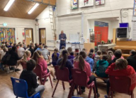
  Learning in the woods!  On Thursday, it was Woodpeckers’ turn to have some learning in the woods! They all had a brilliant time, getting stuck-in and completing their nature riddles and challenges. Next Thursday (11th June), it will be Nightingales’ turn in the afternoon. | 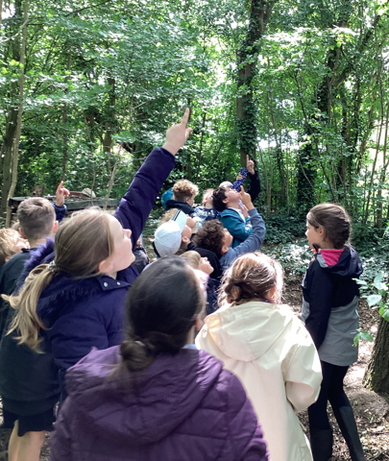
Governors at Combs Ford Primary School
We are still looking to widen our governing body at Combs and would value family members’ skills and expertise to help support the school as we continue to look to improve! If you’re interested in becoming a school governors, please contact the office.
Bitesize Bookworm Competition  TG Jones (formally WH Smith) are running a Bitesize Bookworm Competition with the top prize of a £200 TG Jones gift card and £4,000 of books and stationery for the school. There are three different age groups and a winner and three runner-up prizes in each age group. All you have to do is write a book review of your favourite book in 25 words or less! The closing date is today, Friday 5th June. To enter please go to this website: https://www.tgjonesonline.co.uk/help/policies/competitions-terms/bitesize-bookworms | 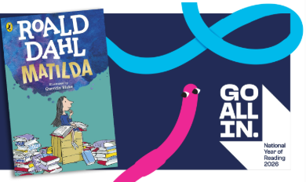
Issues with behaviour outside of school  We have had a couple of local residents who have reported to us about the behaviour of pupils when going home, particularly on bikes and scooters. Please can we politely ask that families speak to their children about being careful when travelling to and from school. | 
  Family Forum  Juts another reminder that we will be holding another Family Forum. This will be another opportunity for families to share their thoughts and views on topics within school. This will be on Thursday 2nd July at 2.45pm. Please sign up for this on Arbor (in trips) so we can get an idea on numbers. | 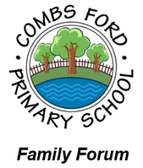

Dates for the Diary
Key: (new) (change of date/time)
Summer Fete- Friday 19th June
Year 1 Trip to Felixstowe - Tuesday 23rd June (All Day)
Year 2 Sewing Afternoon with Families- Wednesday 24th June (1.30pm-3pm)
Year 1 and 2 Sports Festival at Trinity – Thursday 25th June (Time TBC)
TRANSITION MORNING- Monday 29th June (AM)
Lower School Sports Day (Years 1-3) – Tuesday 30th June (9am-10.30am)
TRANSITION AFTERNOON- Tuesday 30th June (PM)
Year 2 Trip to Bury St Edmunds Cathedral – Wednesday 1st July (All Day)
Year 4 Tudor Immersion Afternoon with Families- Thursday 2nd July (1.30pm-3pm)
Family Forum – Thursday 2nd July (2.45pm)
Year 3 Road Dahl Reading Event with Families- Friday 3rd July (1.30pm-3pm)
Upper School Sports Day (Years 4-6) – Tuesday 7th July (9am-10.45am)
EYFS Sports Day- Wednesday 8th July (9.30am -10.30am)
Year 6 Show – Monday 13th July (1.30pm)
Year 6 Show – Tuesday 14th July (9.30am)
Year 6 Leavers Party – Thursday 16th July (4pm-6pm)
Year 6 Leavers Assembly – Friday 17th July (9.15am)
FINAL DAY OF TERM FOR CHILDREN- FRIDAY 17th JULY

Thank you for your continued support,

Mr Wesley, Mrs Aldred, Miss Fuller
Combs Leadership Team
