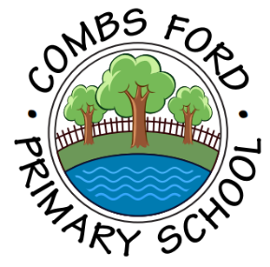
Combs Ford Primary School
Glemsford Road
Stowmarket
Suffolk
IP14 2PN

Telephone: (01449) 613112

email: admin@combsfordprimary.co.uk
Headteacher: Mr Matt Wesley BA (Hons) MA PGCE NPQSL

Combs Ford Primary School News
Be the best that you can be!

Friday 8th May- Issue #31 | Weekly Attendance Winners:  Woodpeckers 98.1%
Happy Friday everyone!
  Family Friday  With our first Family Friday being such a success, we are excited to say that the next event will be on Friday 5th June. We hope that more families will enjoy taking the opportunity to relax and enjoy our school’s lovely facilities in the sunshine again! | 
Year 5 Reading Cafe  On Thursday, we had our Year 5 Reading Together session, where families had to chance to learn about the way in which we teach reading in Year 5, followed by a series of activities to do with their children. Thank you so much to everyone who came to support the event. | 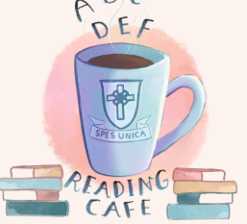
  Learning in the woods!  Owls had a great time in the woods this week, being at one with nature whilst competing to complete a range of fun challenges set by Mrs Moore! | 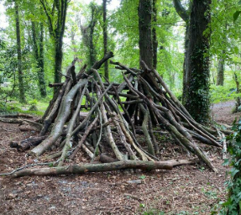
  Dental Nurse Visit  Last week, the children in EYFS-Year 3 were visited by a dental nurse who told us all about how to look after our teeth. Attached to this update is guide to help support good oral health for children. | 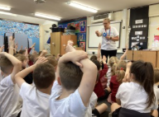
Assembly  In assembly this week, Sam Oldefield was our visitor and she came to Combs to talk about the new recycling system coming into homes on 1st June. The children learnt about how to use the different bins to become Waste Warriors! We have attached extra information about this with this update. | 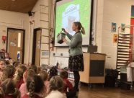
Tennis Superstars!  Last Thursday, 5 terrific tennis players went to Thurston Community College to play in tennis matches against 5 other teams. We were delighted that working hard in their lunchtime practices paid off as they came in Bronze position #BeTheBestYouCanBe  | 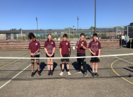
Summer Sports Festival  This week, six Key Stage One children had a wonderful time at Finborough School at the summer sports festival. They got to try tennis, golf, cricket and athletics activities and met lots of children from other schools. | 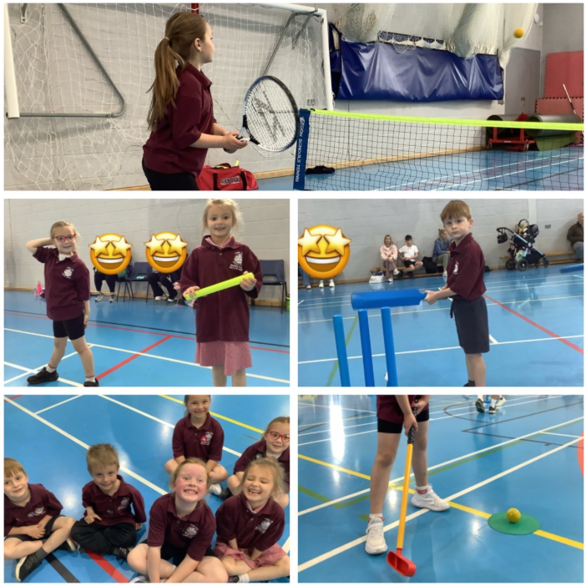
  Rights Respecting School  This week, children have been discussing the rights of the child. They have been finding out how grown-ups make sure their rights are met. We have also been discussing how we feel our rights our met at Combs Ford. This links to articles 1 and 4. | 
Fundraising  Please don’t forget to encourage your child to attempt our £20.26 for 2026 fundraising challenge! They are allowed to achieve this however they like. We still have 2 weeks until the returns date so please keep working away so we can raise funds which will be invaluable in helping us build a new astro-turf! | 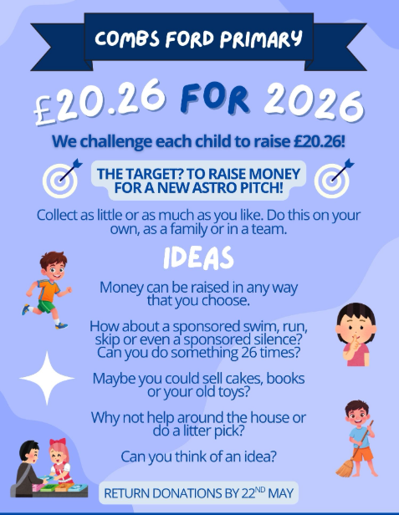

Dates for the Diary
Key: (new) (change of date/time)
Year 1 Walk to Combs Wood – Monday 11th May (PM)
EYFS Plant Seeding with Families – Monday 11th May (2.45pm)
Year 6 Writing Café- Monday 18th May (Sharks 9-10am, Wild Cats 10-11am)
Second Hand Uniform Sale-Tuesday 19th May (3.15pm)
HALF TERM- Monday 25th May- Friday 29th May
Family Friday- Friday 5th June (3.20-4.30pm)
Summer Fete- Friday 19th June
Year 1 Trip to Felixstowe - Tuesday 23rd June (All Day)
Year 2 Sewing Afternoon with Families- Wednesday 24th June (1.30pm-3pm)
Year 1 and 2 Sports Festival at Trinity – Thursday 25th June (Time TBC)
TRANSITION MORNING- Monday 29th June (AM)
Lower School Sports Day (Years 1-3) – Tuesday 30th June (9am-10.30am)
TRANSITION AFTERNOON- Tuesday 30th June (PM)
Year 2 Trip to Bury St Edmunds Cathedral – Wednesday 1st July (All Day)
Year 4 Tudor Immersion Afternoon with Families- Thursday 2nd July (1.30pm-3pm)
Year 3 Road Dahl Reading Event with Families- Friday 3rd July (1.30pm-3pm)
Upper School Sports Day (Years 4-6) – Tuesday 7th July (9am-10.45am)
EYFS Sports Day- Wednesday 8th July (9.30am -10.30am)

Thank you for your continued support,

Mr Wesley, Mrs Aldred, Miss Fuller
Combs Leadership Team
