
Combs Ford Primary School
Glemsford Road
Stowmarket
Suffolk
IP14 2PN

Telephone: (01449) 613112

email: admin@combsfordprimary.co.uk
Headteacher: Mr Matt Wesley BA (Hons) MA PGCE NPQSL

Combs Ford Primary School News
Be the best that you can be!

Friday 23rd January- Issue #19 | Weekly Attendance Winners:  Elephants 99.2%
Happy Friday everyone!
Drawing Club in EYFS  On Weds 4th and 11th February (9.15-10.15), Bear Cub families are invited to come into school to learn about how EYFS teach drawing club and how we teach the foundational skills of writing in the early years! Please sign up for one of these on Arbor. | 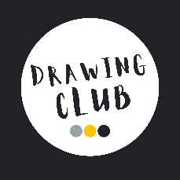
School Council Litter Picking  We have been talking lots about respect and how we look after our environment in school. Our brilliant school council have been hard at work litter picking and have discovered many interesting items littered around the school grounds! | 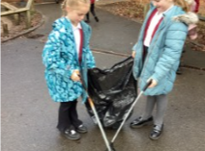
Busy Bear Cubs  Bear Cubs have taken part in Bird Watch Week. They have enjoyed spotting birds and keeping a record of how many they saw. They were very excited to find lots of bluetits building nests in the bushes in the EYFS garden.  Bear Cubs were also lucky to have a visit from Mrs French, a vet nurse. She taught us how to look after pets and she was very impressed with the questions that the children asked. She introduced us to her pet guinea pigs as well. Thank you Mrs French! | 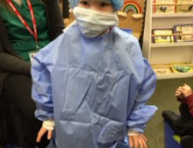
Year 3 and 4 Indoor Athletics  On Tuesday, Mrs Ashton and Mrs Vaughan-Wright took a team of 12 athletes to a Year 3 and 4 indoor festival at Stowmarket Leisure Centre. The children got to try out lots of track events including sprints, relay, obstacle and over/under. They also had a go at the field events which included: long jump, triple jump, speed bounce, chest push and vertical jump. The children thoroughly enjoyed the experience and they were wonderfully behaved. Although it was not a competitive event, they did announce the children with the highest field scores and two of our girls had the best scores in long jump and vertical jump which made us very proud! A big thank you to one of our Year 5 sports leaders who came along to support the children in the event. | 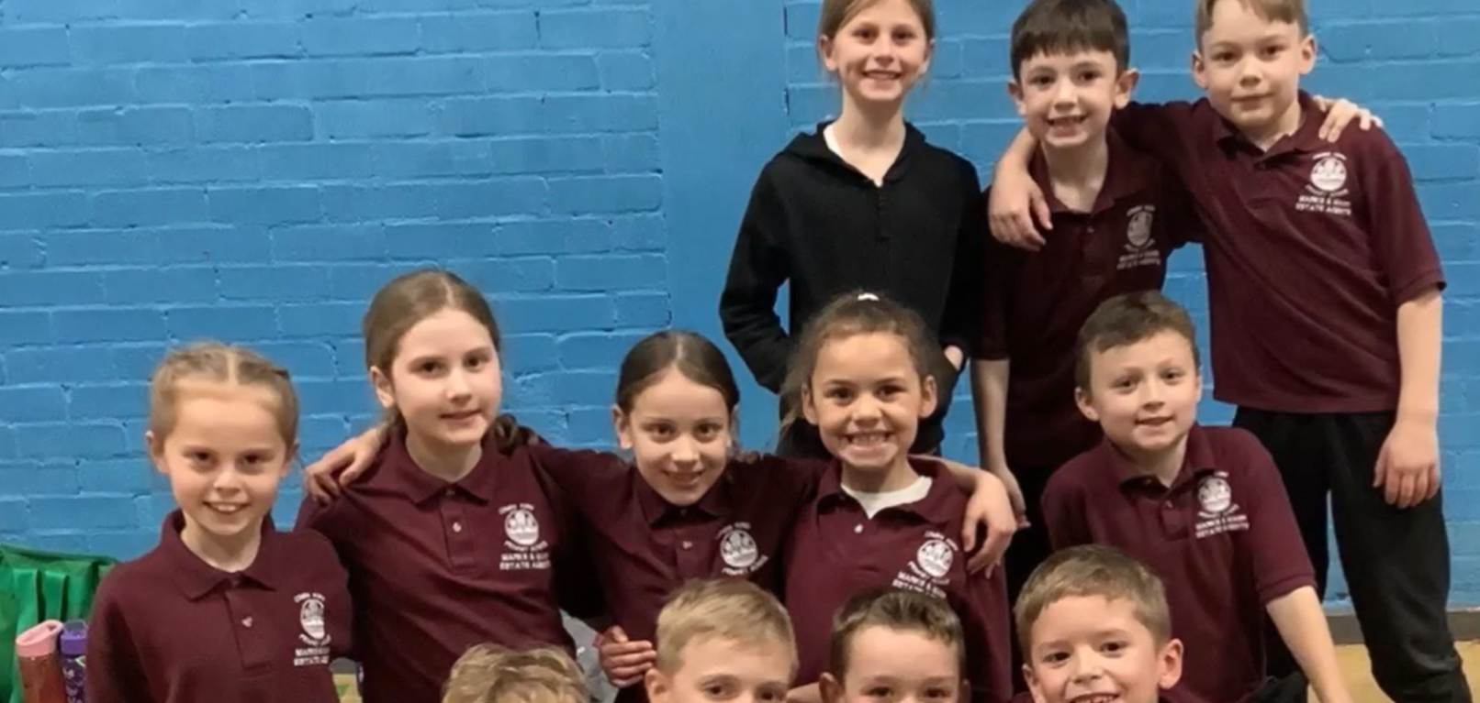
Staff Absence  Miss Fuller is currently unwell and won’t be in school for the next few weeks. We wish her all the best and look forward to her return. In the meantime, please email admin@combsfordprimary.co.uk if you have any SEND related queries and it will get forwarded to the appropriate channels and we will endeavour to respond in a timely manner. Thank you. | 
Parking around School  Please can we remind families to be respectful when parking around the school, as local residents have reported families blocking their drives and parking on their grass verges. Thank you. | 
Office Hours  Please can we remind families that our school Office hours are 8.30am-4.30pm Monday-Thursday and 8.30am-4pm on Fridays. Thank you. | 
What I love about life at Combs- by Louis in Year 6  “The thing I love about Combs Ford is how lovely and inviting our school are to new pupils by helping them learn routines and playing with them. All the pupils are super supportive when someone gets an award or has achieved something really big (which is lovely to see!). Teachers are really kind and comfort you if you are feeling down so you can feel much better.” |   “What I love about life at Combs…”

Dates for the Diary
Key: (new) (change of date/time)
Year 3 Families Residential Meeting for Year 4 in October- Monday 2nd February (5.30pm)
EYFS Drawing Club- Wednesday 4th February (9.15am-10.15am)
EYFS Drawing Club- Wednesday 11th February (9.15am-10.15am)
Family Forum- Wednesday 11th February (2.45pm)
Year 5 Stop Motion Computing Movie Presentation Afternoon- Thursday 12th February (2.30pm)
Half Term- Week commencing Monday 16th February
Year 2 trip to Lackford Lakes – Thursday 12th March (All day)
Year 4 Easter Craft Afternoon with Families- Wednesday 18th March (1.20 PM)
Parents Evening- Thursday 19th March
Parents Evening- Monday 23rd March
Year 2 DT Afternoon with Families- Wednesday 25th March (1.20pm-3.20pm)
Year 6 SATS Easter School- Tuesday 7th and Wednesday 8th April (8.45-Midday)

Thank you for your continued support,

Mr Wesley, Mrs Aldred, Miss Fuller
Combs Leadership Team
