
Combs Ford Primary School
Glemsford Road
Stowmarket
Suffolk
IP14 2PN

Telephone: (01449) 613112

email: admin@combsfordprimary.co.uk
Headteacher: Mr Matt Wesley BA (Hons) MA PGCE NPQSL

Combs Ford Primary School News
Be the best that you can be!

Friday 15th May- Issue #32 | Weekly Attendance Winners:  Woodpeckers 99.4%
Happy Friday everyone!
IQM Quality Mark  We are very excited at Combs Ford to share with families the news that we recently had our Inclusion Quality Mark assessment and have retained our status as a Centre of Excellence! This recognises all the hard work that our staff put in to support children and families.  “Walking around the school provided a strong and immediate sense of a calm, purposeful, and nurturing environment where pupils feel settled and ready to learn. The atmosphere across the school is notably wholesome, with a clear emphasis on creating spaces that support both learning and wellbeing.”  A big thank you to our parents and governor volunteers who took the time to speak to the assessor. | 
  Brilliant Bear Cubs  Bear Cubs enjoyed having their families visit on Monday afternoon. We started by being Brilliant Bookworms and reading instructions to find out how to plant a seed. We then worked with our special people to plant and water the seed. Everyone went home with their own seed to take care of. Don't forget to water your seeds, Bear Cubs! | 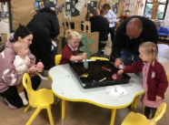
Year 6 SATS  A massive well done to our Year 6 pupils for working so hard in their SATS tests this week! They thoroughly enjoyed their well-deserved trip to the Regal Cinema today to watch the Super Mario Movie. We are very proud of you all! | 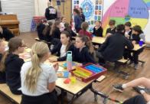
Year 6 Writing Cafe  On Monday 18th May, Year 6 are holding a Writing Learning Together Café with families. It would be lovely for each child to have a family member/ family friend who could come along to this event and learn together with their child. Sharks’ session is at 9am and Wild Cats at 10am. Please sign up for this on Arbor in the Trips section. | 
  Learning in the woods!  Badgers had a wonderful time in the woods this Thursday. They got stuck-in and Mrs Moore was very impressed by their great vocabulary when discussing what they could see and hear in the woodland area. The children were also excited to hear the tapping of a woodpecker and to also spot a pigeon’s egg! Next week, it will be Kestrels’ turn to do some woodland learning! | 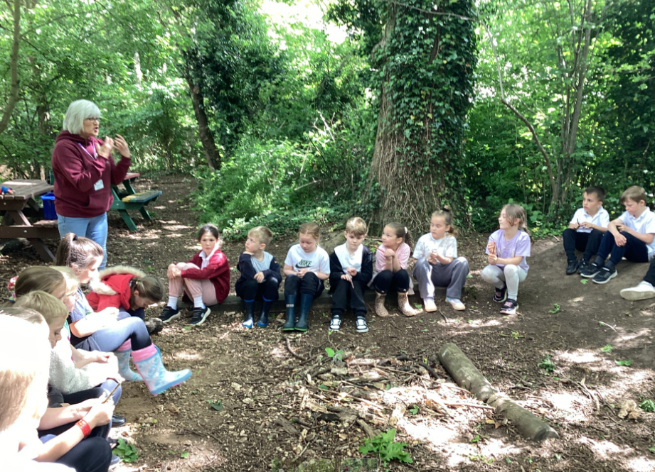
Bitesize Bookworm Competition  TG Jones (formally WH Smith) are running a Bitesize Bookworm Competition with the top prize of a £200 TG Jones gift card and £4,000 of books and stationery for the school. There are three different age groups and a winner and three runner-up prizes in each age group. All you have to do is write a book review of your favourite book in 25 words or less! The closing date is Friday 5th June. To enter please go to this website: https://www.tgjonesonline.co.uk/help/policies/competitions-terms/bitesize-bookworms | 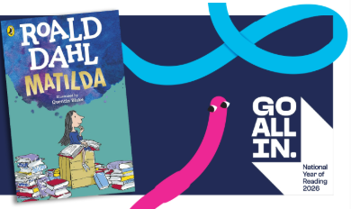
  Year 3 and 4 Athletics  Well done to our Year 3 and 4 athletics team who took part in a festival this week. The 4 events were 50m sprint, 400m run, howler throw and a long jump. We are so proud that one of our Year 3 boys got the fastest overall time for the 400m run and one of our girls got the third fastest time in the same event. | 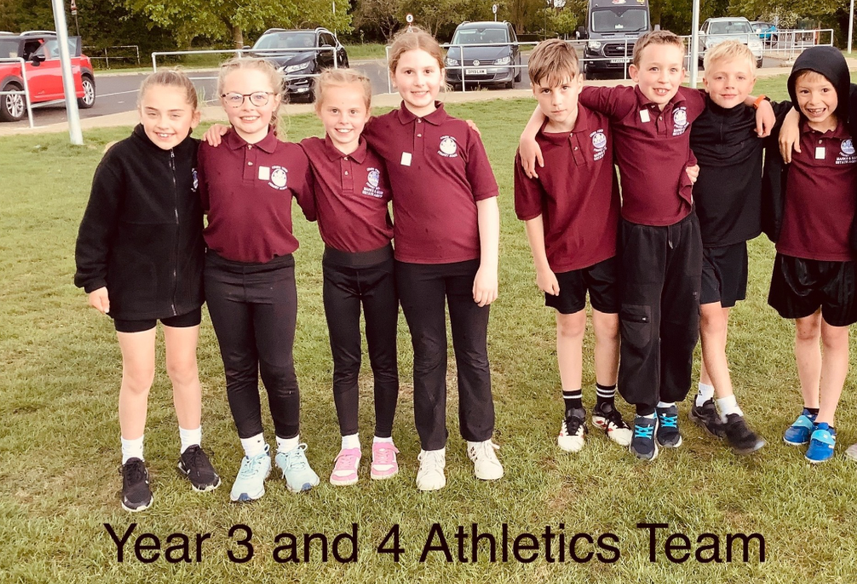
Year 1’s Trip to Combs Wood  On Monday, Year One visited Combs Wood. We explored the surroundings, discussing what we could see and comparing it to the Amazon Rainforest, which we have been learning about in class. The children used a compass to find north and then created their own simple map of the area. | 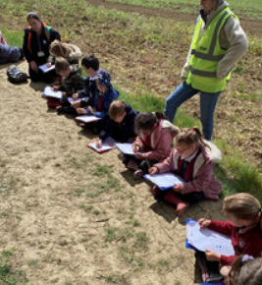
Issues with behaviour outside of school  We have had a couple of local residents who have reported to us about the behaviour of pupils when going home, particularly on bikes and scooters. One neighbour witnessed a child knock down part of her wall with their scooter. Please can we politely ask that families speak to their children about being careful when travelling to and from school. | 
  Rights Respecting School  This week, children have been focussing on Article 3 – The Best Interests of the Chid. They thought about who looks after them and makes sure their rights are protected. Bear Cubs made a list of people who look after them at school and made a big thank you poster. Mrs Lehocz even said that some children popped into the library after lunch to thank her for all of her hard work! | 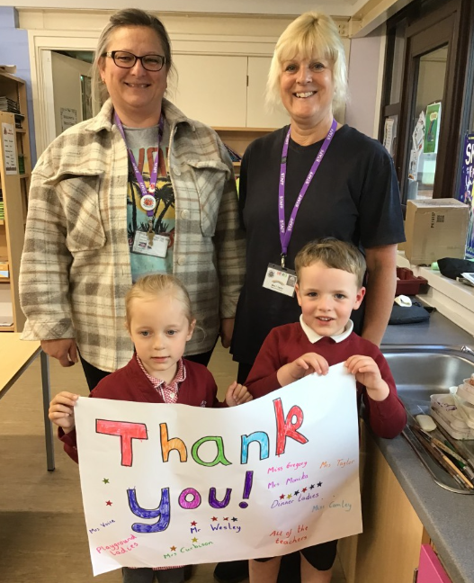
Fundraising  Please don’t forget to encourage your child to attempt our £20.26 for 2026 fundraising challenge! They are allowed to achieve this however they like. We still have 1 week until the returns date so please keep working away so we can raise funds which will be invaluable in helping us build a new astro-turf!  If you have any photos or videos of your children completing their fundraising, we would love to see them and share them in assembly next week! Please forward them to admin@combsfordprimary.co.uk | 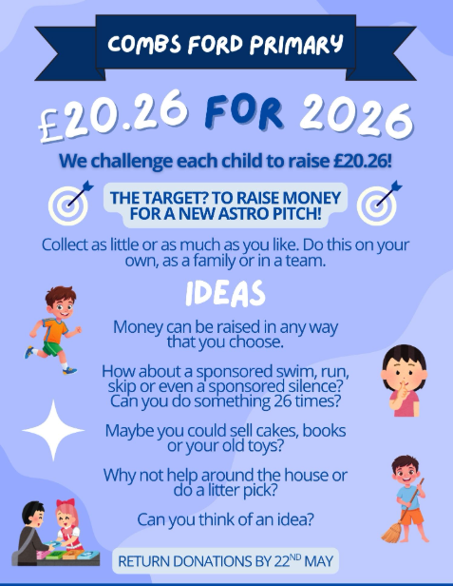

Dates for the Diary
Key: (new) (change of date/time)
Year 6 Writing Café- Monday 18th May (Sharks 9-10am, Wild Cats 10-11am)
Second Hand Uniform Sale-Tuesday 19th May (3.15pm)
HALF TERM- Monday 25th MAY- FRIDAY 29th MAY
Family Friday- Friday 5th June (3.20-4.30pm)
Summer Fete- Friday 19th June
Year 1 Trip to Felixstowe - Tuesday 23rd June (All Day)
Year 2 Sewing Afternoon with Families- Wednesday 24th June (1.30pm-3pm)
Year 1 and 2 Sports Festival at Trinity – Thursday 25th June (Time TBC)
TRANSITION MORNING- Monday 29th June (AM)
Lower School Sports Day (Years 1-3) – Tuesday 30th June (9am-10.30am)
TRANSITION AFTERNOON- Tuesday 30th June (PM)
Year 2 Trip to Bury St Edmunds Cathedral – Wednesday 1st July (All Day)
Year 4 Tudor Immersion Afternoon with Families- Thursday 2nd July (1.30pm-3pm)
Year 3 Road Dahl Reading Event with Families- Friday 3rd July (1.30pm-3pm)
Upper School Sports Day (Years 4-6) – Tuesday 7th July (9am-10.45am)
EYFS Sports Day- Wednesday 8th July (9.30am -10.30am)
Year 6 Show – Monday 13th July (1.30pm)
Year 6 Show – Tuesday 14th July (9.30am)
Year 6 Leavers Party – Thursday 16th July (4pm-6pm)
Year 6 Leavers Assembly – Friday 17th July (9.15am)
FINAL DAY OF TERM FOR CHILDREN- FRIDAY 17th JULY

Thank you for your continued support,

Mr Wesley, Mrs Aldred, Miss Fuller
Combs Leadership Team


