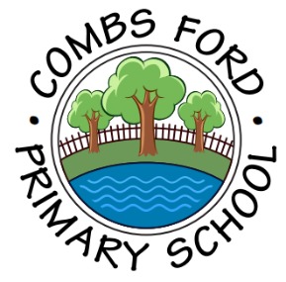
Combs Ford Primary School
Glemsford Road
Stowmarket
Suffolk
IP14 2PN

Telephone: (01449) 613112

email: admin@combsfordprimary.co.uk
Headteacher: Mr Matt Wesley BA (Hons) MA PGCE
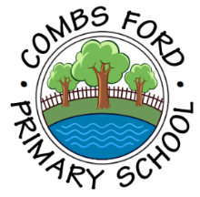
Combs Ford Primary School News
Be the best that you can be!

Friday 5th December 2025- Issue #14 | Weekly Attendance Winners:  Elephants 98%
Happy Friday everyone!
CET Christmas Concert  Last night, children from our choir did a fabulous job when performing at the Corn Exchange in Ipswich at the CET Christmas Concert. It was great to see schools from our Trust come together and showing such confidence to perform in front of hundreds of audience members. It certainly got everyone into the Christmas spirit! | 
Year 5 Geography Trip  Our Year 5 pupils recently enjoyed an exciting local walk as part of their Geography learning. Equipped with Ordnance Survey maps, the children navigated a planned route through Combs Ford, putting their map-reading skills into practice. It was a fantastic opportunity to explore and understand our local area in greater depth.  Along the way, we identified a variety of physical geographical features, such as rivers and green spaces, as well as human features, including roads, bridges, industrial areas and housing. The children were curious and engaged, asking thoughtful questions and making excellent observations about how the landscape has been shaped by both nature and people.  We are proud to say that the children behaved exceptionally well throughout the trip, showing respect for the environment and for each other. This hands-on experience helped bring Geography to life and deepened their understanding of the world around them. | 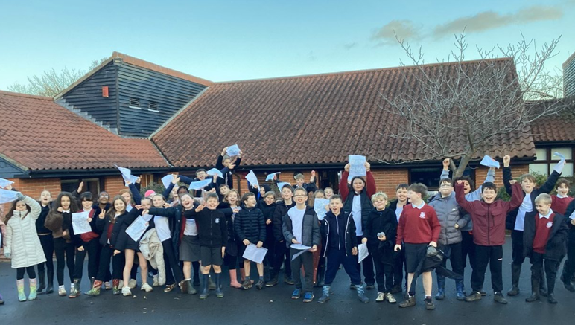  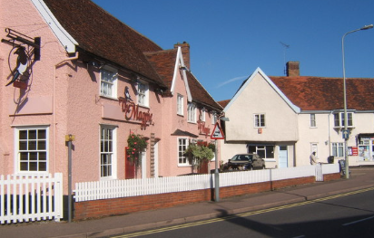
Terrific Tuesday!  Check out our 17 dodgeballers who ducked, dived and fired dodgeballs with passion and determination on Tuesday! It was loud and exciting with a lot of fun had by all! We were so proud of the honesty shown by our children at the event ! | 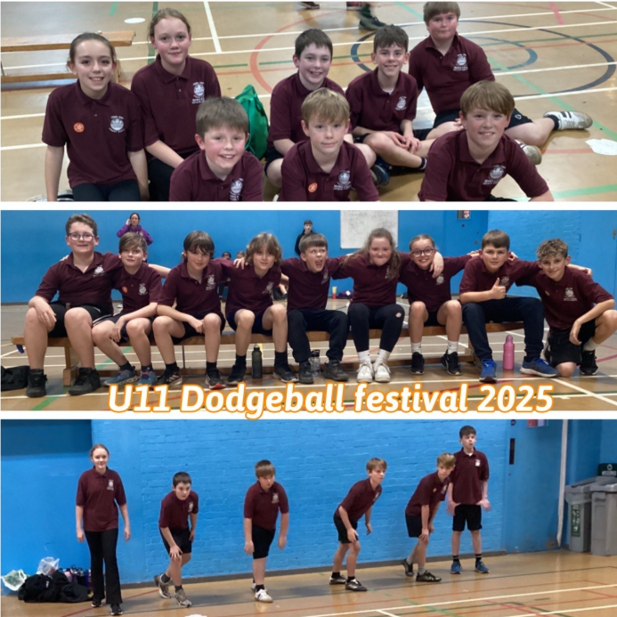
Food Recycling Assembly  On Wednesday 3rd December, Sam Oldfield the waste education officer from Mid Suffolk District Council came to speak to the children in assembly about food recycling and how to be 'food savvy.' The children have been getting used to using the new food recycling bins and this was a great way to help them understand how and why we recycle food. | 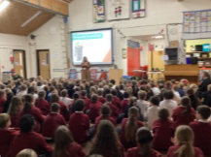
Busy Bear Cubs  Bear Cubs enjoyed a visit from Reverend Sarah this week. She told them all about the first Christmas. Reverend Sarah was very impressed with how Bear Cubs listened and answered questions. She also enjoyed listening to one of their Christmas play songs and thought they were all 'Proud Performers'. | 
Cooking in Year 5  This week, our school hall was filled with excitement and delicious aromas as we hosted a special cooking lesson. Parents joined us to help the children prepare ingredients for an adapted pasta Bolognese sauce recipe. It was a wonderful opportunity for families and students to work side by side, sharing skills and creating lasting memories.  The children demonstrated outstanding listening skills, followed instructions carefully and showed respect for their helpers and each other. They handled the equipment safely and confidently, learning the importance of good kitchen practices and hygiene. From chopping vegetables to stirring the sauce, every child worked hard and persevered, even when tasks were challenging.  This hands-on experience not only taught valuable cooking techniques but also encouraged teamwork, patience, and resilience. A big thank you to all the parents who came in to support—your involvement made the day truly special! | 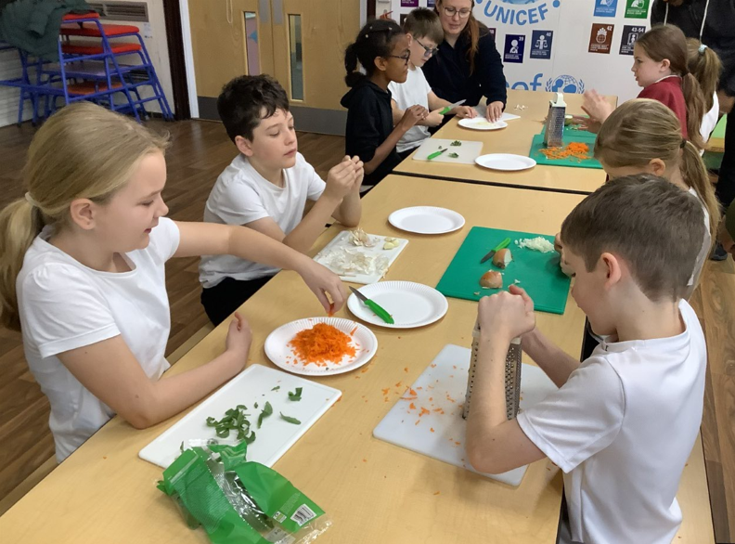
Rock Steady Concerts  A reminder that next week are our Rock Steady Concerts! The Key Stage 1 Families show is at 1.50pm and the Key Stage 2 Families show is at 2.40pm next Thursday 11th December.  The children are looking forward to showing off the songs that they have been working so hard on learning this term! | 
What I love about life at Combs- by Freddie F in Year 6  “I enjoy coming to Combs Ford Primary School because the teachers are incredible and the students are extremely friendly. Playtimes are brilliant because we all need a fresh break away from learning. Luckily, our dinner ladies are marvellous and put in tonnes of hard work to keep our school time amazing. Without a doubt, the lunch we’re given is absolutely delicious. The teachers have been incredible ever since I have been at the school. I love every lesson here; knowing I will get to come back to Combs after each weekend engulfs me with joy!” |   “What I love about life at Combs…”

Dates for the Diary
Key: (new) (change of date/time)
Parent’s/Carer’s Evening – Thursday 11th December
Uniform Sale- Thursday 11th December (3-4pm)
Rock Steady Concerts- Thursday 11th December (1.50pm and 2.40pm)
EYFS Nativity – Monday 15th December (9.30am)
Santa Dash Fundraiser- Monday 15th December PM
KS1 Christmas Show – Tuesday 16th December (9.30am)
KS1 Christmas Show – Wednesday 17th December (1.45pm)
School visit to Combs Church- Wednesday 17th December (am for both groups)
Christmas Lunch- Thursday 18th December
Y4 Christmas Craft afternoon (Parent Event) - Thursday 18th December (1.30 pm)
Christmas Jumper Day – Thursday 18th December
PD Day (School closed to children) – Friday 19th December
Christmas Holidays
First Day of the Spring Term- Monday 5th January
Year 6 Learning Together Reading Café- Thursday 8th January (9-10am Sharks, 10-11am Wild Cats)
Year 2 Introduction to Curious Quests with Families- Wednesday 14th January (9am)
Year 1 Curious Quests ‘Inventuring’ Lesson with Families- Thursday 15th January (9am)
Year 5 Stop Motion Computing Movie Presentation Afternoon- Thursday 12th February (2.30pm)

Thank you for your continued support,

Mr Wesley, Mrs Aldred, Miss Fuller
Combs Leadership Team


