
Combs Ford Primary School
Glemsford Road
Stowmarket
Suffolk
IP14 2PN

Telephone: (01449) 613112

email: admin@combsfordprimary.co.uk
Headteacher: Mr Matt Wesley BA (Hons) MA PGCE NPQSL

Combs Ford Primary School News
Be the best that you can be!

Friday 27th February- Issue #23 | Weekly Attendance Winners:  Woodpeckers 97.6%
We hope everyone had a great half term!
Year 1 Phonics Screening Information  Next Wednesday 4th March at 2.45pm is Year 1’s Phonics Screening Information session. We would love as many family members as possible to come along to this so please sign up for this on Arbor if you’re able to come! | 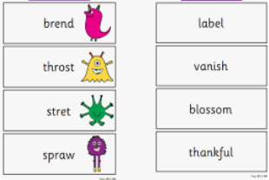
Parents’ Evening  Just a reminder that Parents’ Evenings are Thursday 19th and Monday 23rd March and will run from 3.30pm-6.30pm. Please book your appointment on Arbor. | 
Entries for the school mascot competition  Thank you so much to all the children who entered our school mascot design competition! The school council will soon be sitting down to help shortlist them! | 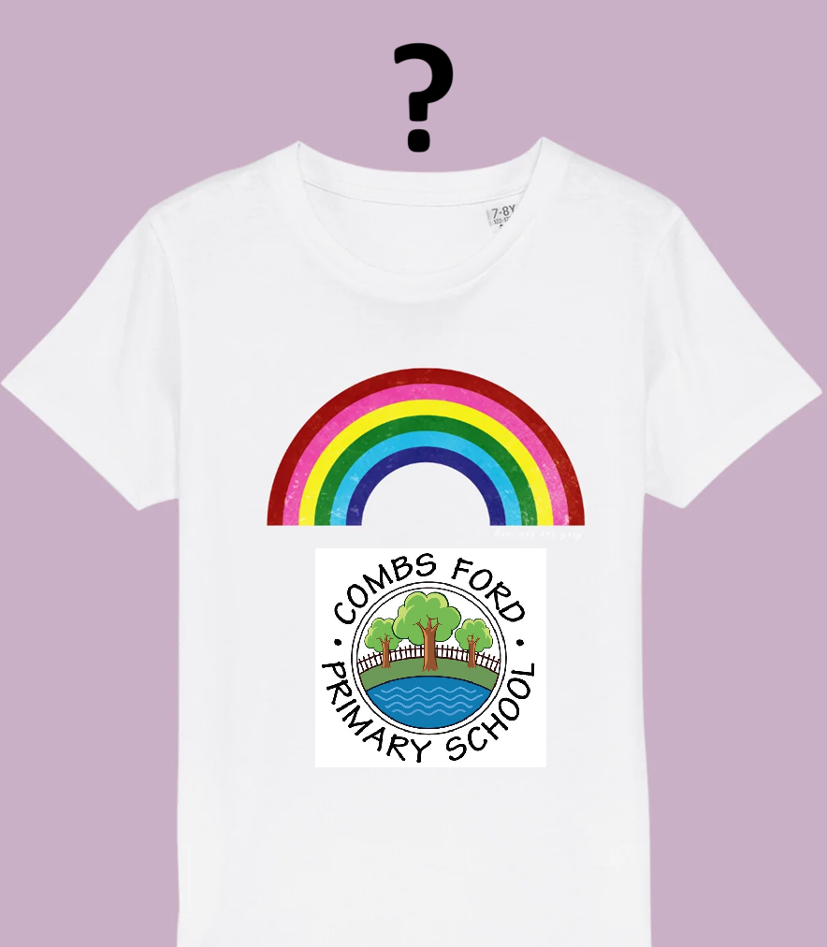
Busy Bear Cubs  Bear Cubs were visited by PC Harvey and PC Taylor this week. They listened carefully to find out how to stay safe on the road and asked some brilliant questions. Thank you to Stowmarket Police for coming to see us! | 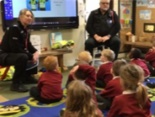
Family Forum  Thank you to everyone who attended our most recent family forum. Our next family forum will be on Wednesday 25th March at 2.45pm. It provided us with some helpful feedback which we have discussed as a teaching staff. Our focus next time will be fundraising and community links. Please sign up for this on Arbor. | 
Community Links  ‘I’ll Be There For You’ offer a range of personalised companionship services designed to bring joy, engagement and support into the lives of the elderly within Stowmarket and Ipswich. Their approach is focused on creating meaningful connections and addressing individual with care and empathy. Head to www.illbethereforyou.co.uk for more information. | 
Friends of Combs Ford Primary  We are very excited that some family members have come forward to help start a fundraising group for the school. They have set up a ‘Friends of Combs Ford Primary School’ Facebook group and would like all family members to join this Facebook page if possible!  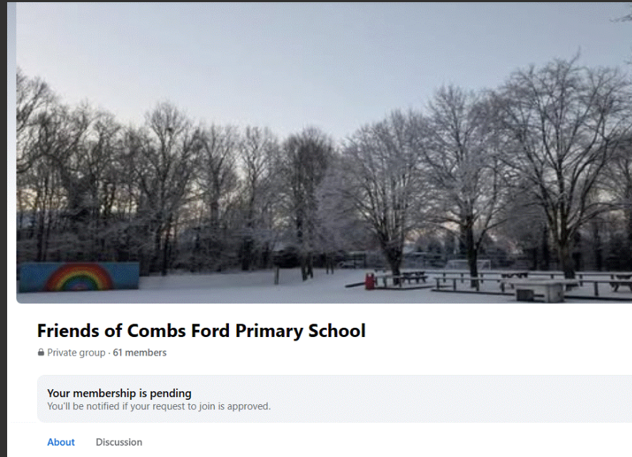 | 
Playing on school grounds  Please can we politely ask that children don’t play in the woodland area of the school or on the school field before or after school. Thank you. | 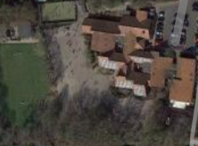
Office Hours  Please can we remind families that our school Office hours are 8.30am-4.30pm Monday-Thursday and 8.30am-4pm on Fridays. Thank you. | 

Dates for the Diary
Key: (new) (change of date/time)
World Book Day- Thursday 5th March
Year 2 trip to Lackford Lakes – Thursday 12th March (All day)
EYFS Mango Tea Party – Thursday 12th March (2.30pm)
Bags 2 School – Monday 16th March
Year 3 Ancient Egypt Activity Afternoon with Families- Monday 16th March (2pm)
Year 4 Easter Craft Afternoon with Families- Wednesday 18th March (1.20 PM)
Year 1 at Colchester Zoo - Wednesday 18th March (All Day)
Parents Evening- Thursday 19th March
Easter Disco- Friday 20th March (Years 1,2,3 – 4.30pm and Years 4, 5 and 6 - 6pm)
Parents Evening- Monday 23rd March
Year 1 DT Puppet Making Afternoon- Monday 23rd March (1.30pm)
Year 2 DT Afternoon with Families- Wednesday 25th March (1.20pm-3.20pm)
Family Forum- Wednesday 25th March (2.45pm)
Year 3 Norwich Castle Trip- Thursday 26th March (All Day)
Year 6 SATS Easter School- Tuesday 7th and Wednesday 8th April (8.45am-Midday)

Thank you for your continued support,

Mr Wesley, Mrs Aldred, Miss Fuller
Combs Leadership Team
