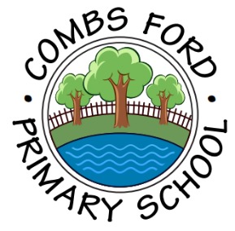
Combs Ford Primary School
Glemsford Road
Stowmarket
Suffolk
IP14 2PN

Telephone: (01449) 613112

email: admin@combsfordprimary.co.uk
Headteacher: Mr Matt Wesley BA (Hons) MA PGCE NPQSL
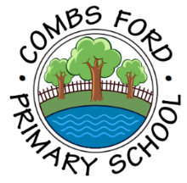
Combs Ford Primary School News
Be the best that you can be!

Friday 16th January- Issue #18 | Weekly Attendance Winners:  Bear Cubs 96.6%
Happy Friday everyone!
Year 1 and 2’s Curious Quests Inventuring Sessions!  Thank you so much to everyone who came along to the Curious Quest Inventuring sessions in Year 1 and 2 this week. The children loved creating their inventions which they will be using as stimulus for their next writing! We hope you enjoyed the opportunity to work alongside your child and gained a good understanding of how wonderful the Curious Quests writing curriculum is! | 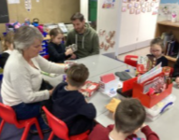
Red Team Point Reward  The Red Team thoroughly enjoyed their reward time with Dr Hall yesterday afternoon and are looking forward to working hard to earn the next one later in the year! | 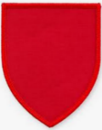    
Year 2’s Amazing Artwork  In Year 2 this week, the children have enjoyed creating expressive paintings using primary and secondary colours! They had great fun and have started some fabulous pieces of artwork... | 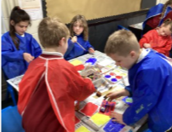
Family Forum  A reminder that our next Family Forum will be on Wednesday 11th February at 2.45pm. We are inviting family members to speak to the Senior Leadership Team to discuss their views on the teaching and learning which is happening at Combs. Please sign up for this on Arbor. You will only need to sign up for this under one child’s name on the system. Thank you. | 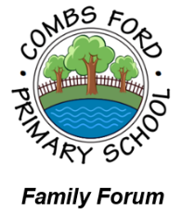
Office Hours  We’d like to remind families that our school Office hours are 8.30am-4.30pm Monday-Thursday and 8.30am-4pm on Fridays. Thank you. | 
Sports Hall Athletics  On Tuesday we took a team of 20 Year 5 and 6s to an indoor athletics event where they competed in 12 track and 12 field events against 6 other schools. Our track events were really strong and we got 2 first places, 18 second places and 4 third places in our heats. All of the points from every event were added up and we were so proud to finish in Bronze position! | 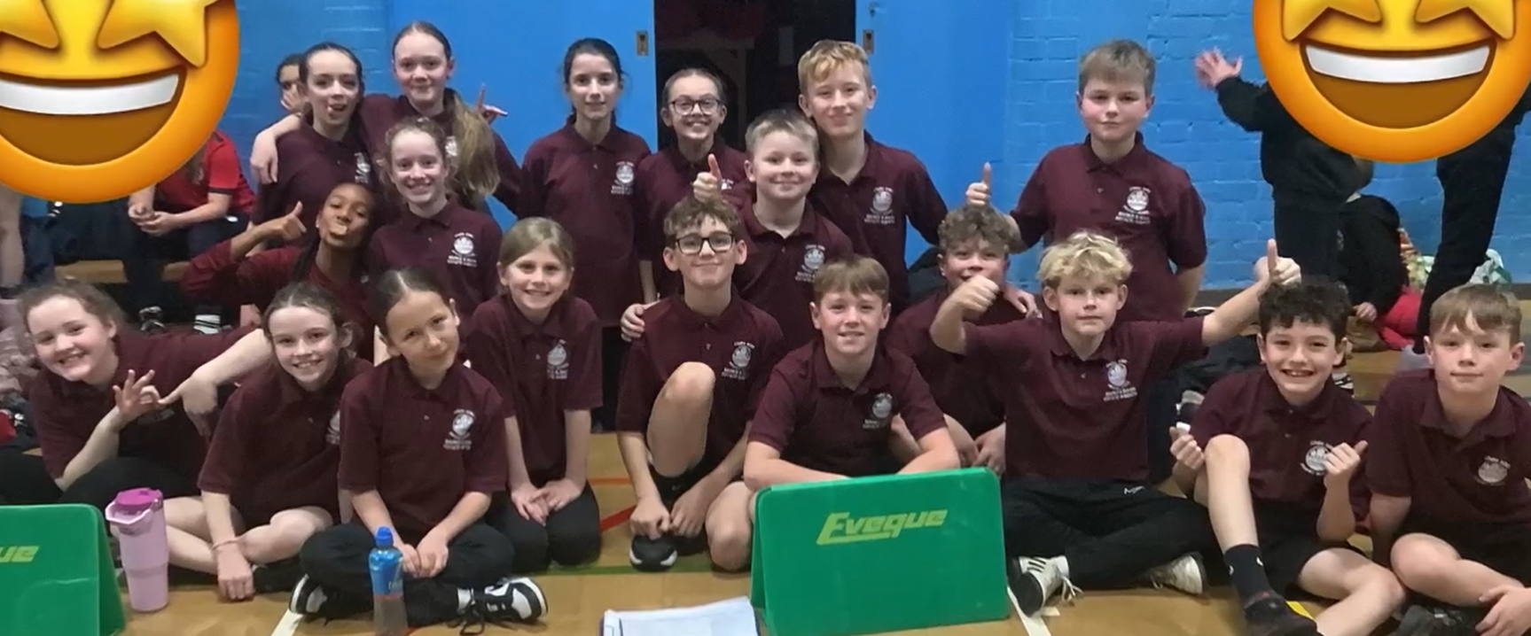
Cross Country  On Thursday, one of our Year 6 girls went to compete in the cross-country Suffolk finals at Woodbridge school. She ran 2.2km around a very hilly course! Well done, we are so proud of you! | 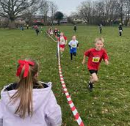
Year 6 Visitor  A student and ex pupil from Northumberland University talked to us about climate change and the consequences it has for sea levels. The children asked lots of thoughtful questions and enjoyed learning from someone who is an expert on the subject. | 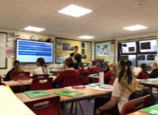
What I love about life at Combs- by Molly in Year 4  “Combs is an amazing school because you get lots of opportunities to try new thing such as music clubs, sports activities and even chess and art club. The teachers and the children are very kind and supportive. If you struggle, everyone is there to give you a helping hand. The school trips are fun and educational and are a great way to start your topics! Combs Ford Primary School is the best- I give it 10/10.” |   “What I love about life at Combs…”

Dates for the Diary
Key: (new) (change of date/time)
Year 3 Families Residential Meeting for Year 4 in October- Monday 2nd February (5.30pm)
Family Forum- Wednesday 11th February (2.45pm)
Year 5 Stop Motion Computing Movie Presentation Afternoon- Thursday 12th February (2.30pm)
Half Term- Week commencing Monday 16th February
Year 2 trip to Lackford Lakes – Thursday 12th March (All day)
Year 4 Easter Craft Afternoon with Families- Wednesday 18th March (1.20 PM)
Parents Evening- Thursday 19th March
Parents Evening- Monday 23rd March

Thank you for your continued support,

Mr Wesley, Mrs Aldred, Miss Fuller
Combs Leadership Team
