
Combs Ford Primary School
Glemsford Road
Stowmarket
Suffolk
IP14 2PN

Telephone: (01449) 613112

email: admin@combsfordprimary.co.uk

Headteacher: Mr Matt Wesley BA (Hons) MA PGCE
Weekly Attendance
Winners:
Elephants
99.1%

Friday Update
(21st November 2025)

Happy Friday everyone!
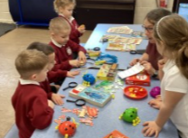
Year 1’s History Visit
Anna from the Food Museum came to visit and the children looked at the collection of toys she had. They compared toys from the past with toys from more recent times. The children loved playing with the toys and being history detectives!
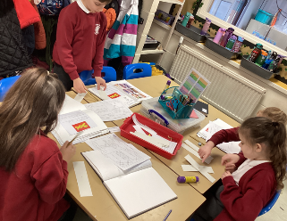
Year 2’s Brilliant DT Day!
Year 2 enjoyed their first DT day making moving monsters. They explored levers and linkages and then designed and made their own moving monster for younger children - they worked so hard and had a great day! Thanks to all the parents who kindly gave up their time to help!
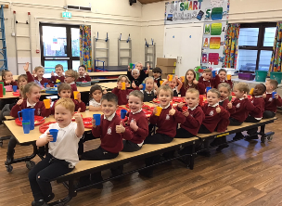
Busy Bear Cubs
This week Bear Cubs started having an option of milk at lunchtime. As you can see, this has been very popular and we like helping our teeth and bones to grow nice and strong!

Second Hand Book Sale and Children in Need
Thank you to all families who supported out second-hand book sale which made £42 for the school! And a well done to everyone who helped to raise £168 for Children in Need!

Gingerbread House Fundraiser
Thank you for everyone so far who has purchased tickets for our gingerbread house fundraiser! It’s not too late to purchase a raffle ticket on Arbor School Shop to be in with the chance of bagging this amazing prize!

Medical Appointments
Please can we remind all families that whenever your child has a medical appointment that the office require proof of the appointment so they can authorise the absence. Thank you.

Raising money for school- for free!
Did you know that whenever you buy anything online - from your weekly shop to your annual holiday - you could be collecting free donations for Combs Ford Primary School? There are over 3,000 shops and sites on board ready to make a donation, including Amazon, John Lewis, Aviva, Trainline and Sainsbury's – it doesn't cost you a penny extra!
1. Scan the QR Code and sign up as a supporter of Combs Ford.
2. Every time you shop online, go to easyfundraising first to find the site you want and start shopping.
3. After you’ve checked out, that retailer will make a donation to your good cause for no extra cost whatsoever! There are no catches or hidden charges and Combs Ford Primary will be really grateful for your donations.

Dates for the Diary
Key: (new) (change of date/time)

Family Forum- Wednesday 26th November (2.30pm)
Y5 Local Walk - Thursday 27th November
Y5 Cooking (Parent Event) - Tuesday 2nd December
Parent’s/Carer’s Evening – Wednesday 3rd December
CET Christmas Concert Ipswich – Thursday 4th December
Parent’s/Carer’s Evening – Thursday 11th December
Uniform Sale- Thursday 11th December (3-4pm)
EYFS Nativity – Monday 15th December (9.30am)
Santa Dash Fundraiser- Monday 15th December PM
KS1 Christmas Show – Tuesday 16th December (9.30am)
KS1 Christmas Show – Wednesday 17th December (1.45pm)
School visit to Combs Church- Wednesday 17th December (am for both groups)
Christmas Lunch- Thursday 18th December
Y4 Christmas Craft afternoon (Parent Event) - Thursday 18th December (1.30 pm)
Christmas Jumper Day – Thursday 18th December
PD Day (School closed to children) – Friday 19th December

Thank you for your continued support,

Mr Wesley, Mrs Aldred, Miss Fuller
Combs Leadership Team
